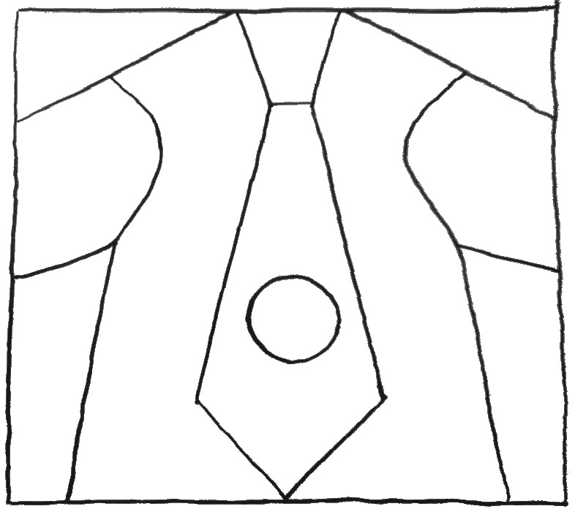

Something From Nothing by Phoebe Gilman

Print the out this pattern. Have someone help you cut on the lines to make a puzzle.

Remove pieces of the puzzle to make a blankie, a coat, a vest, a tie, and a button.

To see how each piece of clothing was made, go to
https://storytiming.com/2011/07/15/flannel-friday-something-for-nothing-or-joseph-had-an-overcoat/
and scroll down to see the pictures.

