This week looks a bit different. We want to give families a chance to catch up on assignments, and explore some of the resources we shared last week. We are focusing on Spring this week.
* Each day there will be a Form to fill out, checking boxes about what activities you did. This counts as attendance for each day. Monday’s is called “Monday’s Activities for 4-6-20.”

Here are a few ideas of Learning Activities that you can choose for this week:
Read a story together.

Explore ABCMouse.com.

Check out Scholastic Classroom Magazine’s Week 4 Week 3 is also available and includes several springtime animal stories and activities.

Join us on Zoom on Tuesday, April 6th at 11 a.m.

Do a Hands-on activity (Making a pattern, measuring, building toys, Playdoh, etc.)
Here are a few ideas you could try:

Chalk Counting Garden 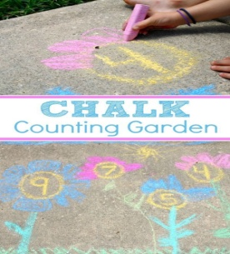
Weathering permitting-go outside and draw a chalk garden. Write the number in the middle for your child to draw petals on a flower.

Coffee Filter Rainbows 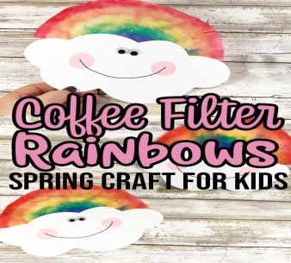
Using a coffee filter and water paint, create a rainbow weather cloud. Feel
free to write your name on your cloud.
*You can use plain paper and markers if you don’t have water paint. Once your child is done coloring, spray the
colored area lightly with water and it will run to look like paint.

Spring Flower Alphabet Match

Spring Sensory Play
Fill a plastic tub with rice/dried beans (using whatever you have at home)
and plastic bugs, caterpillars or butterflies, toy carrots, or other items you have at home
that remind us of spring. Your child could use their fingers, spoons and cups, or tongs to
dig out the bugs or pull up the carrots from the “garden.”

Brain Breaks or GoNoodle Movement Fun
Jack Hartman - Spring
https://www.youtube.com/watch?v=udrIY0nts-E

Jack Hartman - Crossover
https://www.youtube.com/watch?v=GkrZBsOlt3k

The Learning Station - Spring is Here
https://www.youtube.com/watch?v=DobrRgD5aOU

GoNoodle - Trolls: Can’t Stop the Feeling
https://www.youtube.com/watch?v=KhfkYzUwYFk

Mrs. Arco’s Music Videos

Don’t forget to spend time outside (Take a walk, play a game, Bring your camera to do a Photo Hunt where you take pictures of Spring animals, flowers, etc. you see outside)

Spring Crafts
Butterfly Mosaic 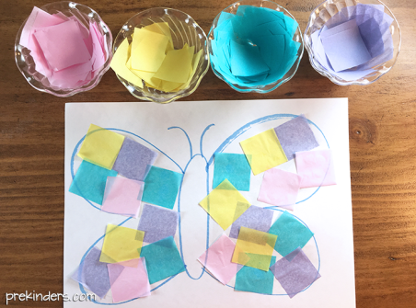

Fork Flowers (Use a plastic spoon and paint to create a Springtime floral arrangement)
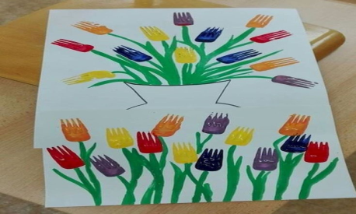

Family Flowers
Using straws and paper design a flower with your child for each family member,
tracing your hand for the petals. You can add them to a vase and keep it on your
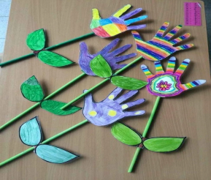
table to serve as a reminder that family sticks together with love and respect.
Talk about the similarities of people and flowers. Things flowers need to
grow and live. Food, water, sunshine, air, vitamins.

