At Home Learning Schedule for UPK
Date: Mon. 6/8
TIME | SUBJECT | RESOURCES
8:00-8:30 | Songs, calendar, weather, days of the week, letter of the week, go over the daily schedule. Talk about the day's activities.  QOTD: How do you make a shadow that has color?  PK.SEL.6. Understands and follows routines and rules  PK.SOC.6. Develops an understanding of how people and things change over time and how to relate past events to their present and future activities  PK.MATH.1 Count up to 20 | "12 Months" by The Laurie Berkner Band  https://www.youtube.com/watch?v=_Qv58l5o6ew  “Primary Colors Song” (Sesame Studio)  https://safeYouTube.net/w/JNeK
8:30-9:00 | Value of the Month: Friendship  Graduation Cap  Standard: PK.SEL.4. Develops positive relationships with their peers  PK.SEL.4.b Interacts with other children (e.g. in play, conversation, etc.)  PK.SEL.4.e Develops friendship with one or more peers | Make a Graduation Cap  16” strip of ribbon  22”x2.5” strip of black or green construction paper  8” x 8” square of black or green cardstock paper (or  construction paper with cardboard underneath to  strengthen it)  Tape  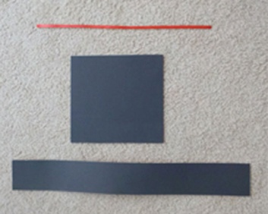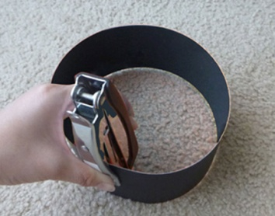  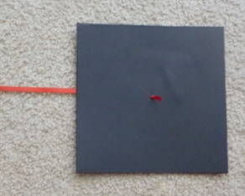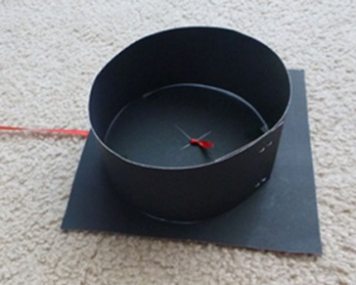  For more information, see: https://www.instructables.com/id/DIY-Preschool-Graduation-Cap-and-Gown/
9:00-9:30 | Puzzle, game of choice  PK.PDH.5. Demonstrates eye-hand coordination and fine motor skills
9:30-9:45 | Body Break  Standard: PK.PDH.3.b. Maintains balance during sitting, standing, and movement activities | Trolls: Can’t Stop the Feeling – GoNoodle  https://safeYouTube.net/w/PPeK  “Rock Your Body to the Colors” – Jack Hartmann  https://safeYouTube.net/w/dSeK
9:45-10:30 | ELA - Read Aloud/Daily Name Writing/ Practice Writing letters  Daily Name Writing - First and last name  Read aloud- Mouse Paint  by Ellen Stoll Walsh  Standard: PKELA.1.d Recognizes and names some upper/lowercase letters of the alphabet, especially those in one’s own name.  PK.ELAL.20: Interact with diverse formats and texts.  PK.ELAL.4: Displays emergent reading behaviors with purpose and understanding | Mouse Paint by Ellen Stoll Walsh  https://safeYouTube.net/w/DGeK  Water Balloon Color Mixing  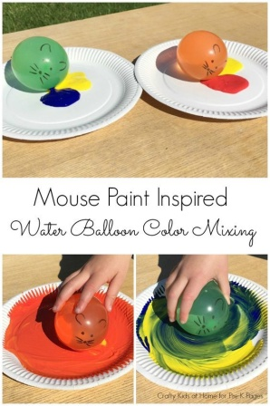  or Color Palette, Color Plate  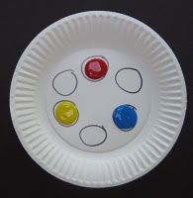
10:30-11:15 | Math-  Crayon Ten Frame  or  Toy Ten Frame  Standard: PK.MATH.3. a When counting objects, says the number names in the standard order, pairing each object with one and only one number name and each number name with one and only one object. (1:1 Correspondence) | The Crayons’ Book of Numbers by Drew Daywalt  https://safeYouTube.net/w/HAdK  Crayon Ten Frame (draw a ten frame on paper)  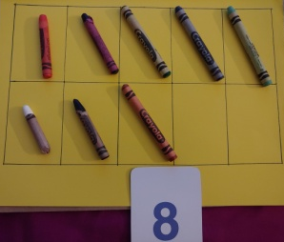  1.) Choose a number card from 1-10 (backpack)  2.) Have your child count out that many crayons.  3.) Put one crayon in each box until you reach the number.  4.) For numbers over 5, go to the left to start the 2nd row. This “return sweep” is also used in reading.  Toy Ten Frame  (Same steps as above, but replace “crayons” in step 2 with “toys.”)
11:15-11:45 | Special - Music  PK.ARTS.9. [MU:Pr4-6.PK] Performs Music | Please see Mrs. Arco’s Class page http://arcomusicinstruction.weebly.com/
11:45-12:15 | Science/ Social studies  Color Shadows  Standard: PK.SCI.9a. Discusses the effects of the sun (provides light, creates shadows)  PK.ELAL.23. Creates a visual display (e.g., drawing, art work, building, writing) | 3 Water bottles  Food Coloring (Red, Yellow, Blue)  1.) Make color bottles by adding food coloring to water bottles and shaking them.  2.) Set a white paper behind them, and shine a flashlight to see the shadow. (Tip: Turning off the light in the room will let the shadows show up better.)  Please take a picture of this activity if you can to share with Mrs. Brands on Google Classroom, or on Seesaw. “Flat Mrs. Brands” would have fun looking at your shadows too!
12:15-1:00 | Lunch -  PK.PDH.8. Demonstrates awareness and understanding of healthy habits | Your child can assist you in setting the table, getting the necessary items out to make lunch. (bread, cold cuts, P.B., jelly, milk, plates, napkins, cups)
1:00-1:45 | Recess  PK.PDH.6. Engages in a variety of physical fitness activities | Relay race, red light green light, free play outside
1:45-2:00 | Story of choice /discuss what you learned today and what you enjoyed doing. Rest and relax!  PK.ELAL.22. [PKSL.4] Describes familiar people, places, things and events  PK.ELAL.24. [PKSL.6] Expresses thoughts, feelings, and ideas | Sample Questions: What was your favorite part of today? What did you enjoy the most?  Name one thing that you learned today?  REST TIME Music  https://www.youtube.com/watch?v=Lp6XlsBm_Lw

Date: Tuesday, 6/9
TIME | SUBJECT | RESOURCES
8:00-8:30 | Songs, calendar, weather, days of the week, letter of the week, go over the daily schedule. Talk about the day's activities.  QOTD: What is 1 fact you know about dinosaurs?  PK.SEL.6. Understands and follows routines and rules  PK.SOC.6. Develops an understanding of how people and things change over time and how to relate past events to their present and future activities  PK.SCI.8. [P-ESS2-1.] Asks questions, makes observations, and collects and records data using simple instruments to recognize patterns about how local weather conditions change daily and seasonally. | Days Of The Week Addams Family (Parody) | Fun songs for Big Kids, Preschoolers and Toddlers  https://www.youtube.com/watch?v=8GKmCQOy88Y  You can clap if you cannot snap!  12 Months of the Year Jack Hartmann  https://www.youtube.com/watch?v=omkuE6Wa5kQ
8:30-9:00 | Value of the Month: Friendship  Forever Friends  Standard: PK.SEL.4. Develops positive relationships with their peers  PK.SEL.4.b Interacts with other children (e.g. in play, conversation, etc.)  PK.SEL.4.e Develops friendship with one or more peers | Listen to “Forever Friends” by Teresa Jennings.  https://safeYouTube.net/w/TxdK
9:00-9:30 | Puzzle, game of choice  PK.PDH.5. Demonstrates eye-hand coordination and fine motor skills
9:30-9:45 | Body Break  Standard: PK.ARTS.2 Performs Dance (A) Demonstrates basic full body movements (crawl, walk, run), non locomotor movements (bend, twist, reach) and spatial relationships (over, under, around) while moving in general space. | “We Are the Dinosaurs” by Laurie Berkner  https://www.youtube.com/watch?v=vPrmY7labLA  “The Dinosaur Dance” – Miss Linky  https://safeYouTube.net/w/gbfK  “Dinosaur Stomp” (Dance-A-Long) –Koo Koo Kanga Roo GoNoodle  https://safeYouTube.net/w/iZeK
9:45-10:30 | ELA - Read Aloud/Daily Name Writing/ Practice Writing letters  Read Aloud – Oh My, Oh My, Oh Dinosaurs by Sandra Boynton  and  Dinosaur Dance by Sandra Boynton  Standard: PKELA.1.d Recognizes and names some upper/lowercase letters of the alphabet, especially those in one’s own name.  PK.ELAL.20: Interact with diverse formats and texts.  PK.ELAL.4: Displays emergent reading behaviors with purpose and understanding | Listen to Oh My, Oh My, Oh Dinosaurs by Sandra Boynton  and Dinosaur Dance by Sandra Boynton read by Mrs. Brands  Dinosaur Swamp Writing Tray  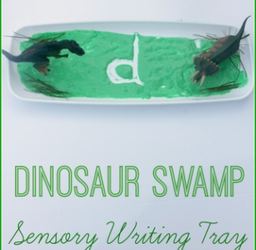  Mix 6 Tablespoons of water and green food coloring. In a tray, add 3 Tablespoons of flour and mix it with the water and food coloring solution.  Add more flour or water as needed.  Use your finger to write letters.  or  Build your name with Magnetic Letters  Challenge: Choose a dinosaur from the book and try to build its name with magnetic letters (Note: you can pause the video on the page with one of the dinosaur names)
10:30-11:15 | Math-  Digging for Dinosaur Bones  Standard: PK.MATH.1. Counts to 20,  Describes and compares measurable attributes  PK.MATH.10. Identifies measurable attributes of objects, such as length, and describes them using appropriate vocabulary | Bone-shaped toys, or a drinking straw cut into pieces that are different sizes  Bowl of dirt  Plastic spoon or shovel  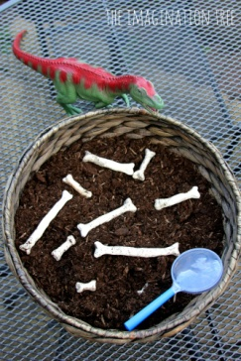  Count how many bones you uncover,  or put the bones in size order from shortest to longest,  or use the color links from your backpack to measure how many links is the length of each dinosaur bone.
11:15-11:45 | Special - Music  PK.ARTS.9. [MU:Pr4-6.PK] Performs Music | Please see Mrs. Arco’s Class page http://arcomusicinstruction.weebly.com/
11:45-12:15 | Science/ Social studies  Standard: PK.SCI.5.b Recognizes the different structures of familiar animals (e.g., eyes, ears, mouth, arms, legs for animals) | Dinosaur Fossils  Dinosaur toys  Playdoh / Salt Dough / Cookie Dough  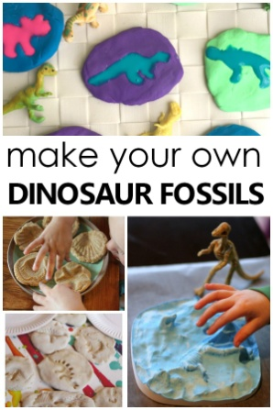Visit this website to find recipes https://www.fantasticfunandlearning.com/fossil-fun-for-kids.html
12:15-1:00 | Lunch  PK.PDH.8. Demonstrates awareness and understanding of healthy habits | Your child can assist you in setting the table, getting the necessary items out to make lunch. (bread, cold cuts, P.B., jelly, milk, plates, napkins, cups)
1:00-1:45 | Recess  PK.PDH.6. Engages in a variety of physical fitness activities | Relay race, red light green light, free play outside
1:45-2:00 | Story of choice /discuss what you learned today and what you enjoyed doing. Rest and relax!  PK.ELAL.22. [PKSL.4] Describes familiar people, places, things and events  PK.ELAL.24. [PKSL.6] Expresses thoughts, feelings, and ideas | Sample Questions: What was your favorite part of today? What did you enjoy the most?  Name one thing that you learned today?  REST TIME Music  https://www.youtube.com/watch?v=Lp6XlsBm_Lw

Date: Wednesday, 5/13
TIME | SUBJECT | RESOURCES
8:00-8:30 | Songs, calendar, weather, days of the week, letter of the week, go over the daily schedule. Talk about the day's activities.  QOTD: What animal starts with X? (Hint: Today’s Read Aloud is filled with animals)  PK.SEL.6. Understands and follows routines and rules  PK.SCI.8. Asks questions, makes observations, and collects and records data using simple instruments to recognize patterns about how local weather conditions change daily and seasonally. | Sesame Street: Usher's ABC Song  https://www.youtube.com/watch?v=SWvBAQf7v8g  Counting to 100  https://www.youtube.com/watch?v=0TgLtF3PMOc
8:30-9:00 | Please visit Coach L’s Google Classroom. | Visit Coach L.’s Google Classroom to check out fun new workout videos!  Fill out your Fitness Tracker and send it to Coach L.
9:00-9:30 | Puzzle, game of choice  PK.PDH.5. Demonstrates eye-hand coordination and fine motor skills
9:30-9:45 | Body Break  Standard: PK.ARTS.2 Performs Dance (A) Demonstrates basic full body movements (crawl, walk, run), non locomotor movements (bend, twist, reach) and spatial relationships (over, under, around) while moving in general space. | “A-B-C, Easy as 1-2-3” by ABCmouse.com (originally by The Jackson 5)  https://safeYouTube.net/w/gchK  Count by 2’s, Dancing 2’s – Jack Hartmann  https://safeYouTube.net/w/GehK  “My Energy” by The Laurie Berkner Band https://www.youtube.com/watch?v=qKcs_oefYyk
9:45-10:30 | ELA - Read Aloud/Daily Name Writing/ Practice Writing letters  Read Aloud – Eric Carle’s ABC  Standard: PK.ELAL.4: Displays emergent reading behaviors with purpose and understanding  PK.SCI.5 Plans and Conducts investigations to determine how familiar plants use their external parts to help them survive in the environment. | Listen to Eric Carle’s ABC read by Mrs. Brands  Post-it notes or Paper cards with letters written on them, and tape.  Tape the letter cards in random order around the room, house, or backyard.  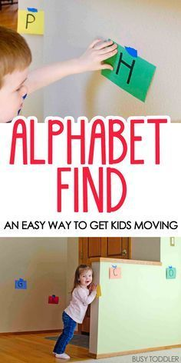  Have your child hunt for the letters in alphabet order.
10:30-11:15 | Math-  “Crayon Counting”  Standard: PK.MATH.1. Counts to 20  PK.MATH.2 Represents a number of objects (0-5), with a written numeral 0-5. | Listen to “The Crayon Counting Book” by Pam Muñoz Ryan.  Use crayons to build the numerals for 11-20.  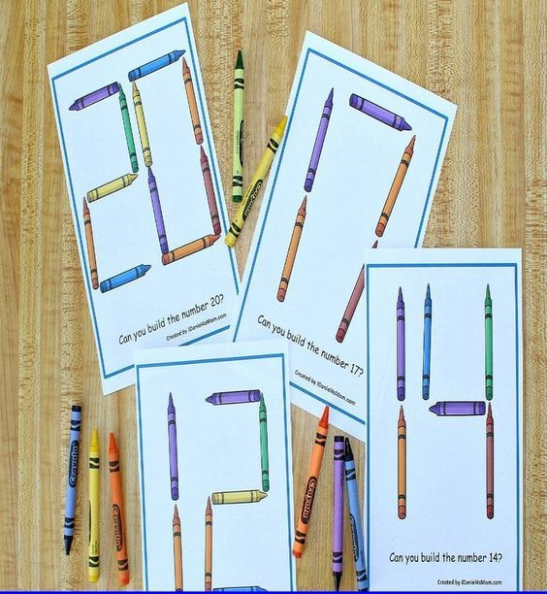  Use your number cards to see what each number should look like.
11:15-11:45 | Value of the Month: Friendship  Standard: PK.SEL.4. Develops positive relationships with their peers  PK.SEL.4.b Interacts with other children (e.g. in play, conversation, etc.)  PK.SEL.4.e Develops friendship with one or more peers | Circle Time on Zoom at 11:00
11:45-12:15 | Science/ Social studies-  Zoo Animal Wheel  Standard: PK.SCI.4.a Explores what a variety of living organisms need to live and grow (e.g. water, nutrients, environment)  PK.ELAL.22. [PKSL.4] Describes familiar people, places, things and events | 1. Log in to abcmouse.com/login  2. Click on your child’s picture.  3. Click on “About Me.”  4. Click on “My Lessons.”  5. Open the playlist called "June”  6. Have your child play “Zoo Animal Wheel”
12:15-1:00 | Lunch  PK.PDH.8. Demonstrates awareness and understanding of healthy habits | Your child can assist you in setting the table, getting the necessary items out to make lunch. (bread, cold cuts, P.B., jelly, milk, plates, napkins, cups)
1:00-1:45 | Recess  PK.PDH.6. Engages in a variety of physical fitness activities | Relay race, red light green light, free play outside
1:45-2:00 | Story of choice /discuss what you learned today and what you enjoyed doing. Rest and relax!  Standard: PKELA.20. {PKSL.2.} Interacts with diverse formats and texts (Shared read alouds, video clips, oral storytelling)  PKELA.22.{PKSL.4} Describes familiar people, places, things and events | Sample Questions: What was your favorite part of today? What did you enjoy the most?  Name one thing that you learned today?  REST TIME Music  https://www.youtube.com/watch?v=Lp6XlsBm_Lw
Date: Thursday 6/11
TIME | SUBJECT | RESOURCES
8:00-8:30 | Songs, calendar, weather, days of the week, letter of the week, go over the daily schedule. Talk about the day's activities.  QOTD: What would you not let the pigeon do?  PK.SEL.6. Understands and follows routines and rules  PK.SOC.6. Develops an understanding of how people and things change over time and how to relate past events to their present and future activities  PK.SCI.8. [P-ESS2-1.] Asks questions, makes observations, and collects and records data using simple instruments to recognize patterns about how local weather conditions change daily and seasonally. | 12 Months of the Year Jack Hartmann  https://www.youtube.com/watch?v=omkuE6Wa5kQ  Days of week  https://www.youtube.com/watch?v=Oiisv7EhG98
8:30-9:00 | Value of the Month: Friendship  Standard: PK.SEL.4. Develops positive relationships with their peers  PK.SEL.4.b Interacts with other children (e.g. in play, conversation, etc.)  PK.SEL.4.e Develops friendship with one or more peers | Talk about some games you loved playing with your friends this year.  Call a friend to say “Hello” over the phone.
9:00-9:30 | Puzzle, game of choice  PK.PDH.5. Demonstrates eye-hand coordination and fine motor skills
9:30-9:45 | Body Break  Standard: PK.ARTS.2 Performs Dance (A) Demonstrates basic full body movements (crawl, walk, run), non locomotor movements (bend, twist, reach) and spatial relationships (over, under, around) while moving in general space. | The Elephant and Piggie Dance Game  http://pigeonpresents.com/dance/  “Shake Something” by Hap Palmer  https://www.youtube.com/watch?v=rDaa7Q2so-s
9:45-10:30 | ELA - Read Aloud/Daily Name Writing/ Practice Writing letters  Read Aloud – Don’t Let the Pigeon Drive the Bus by Mo Willems  Standard: PKELA.1.1 Demonstrates understanding of the organization and basic features of print.(D) recognizes and names some upper/lowercase letters of the alphabet, especially those in one’s own name. | Don’t Let the Pigeon Drive the Bus by Mo Willems  https://safeYouTube.net/w/NgfK  Writing: Don’t let the Pigeon…  Draw a picture and use letters to label what you would not let the pigeon do.  Take a picture to share with Mrs. Brands on Google Classroom if you can!
10:30-11:15 | Science/ Social studies  Icy Bus Rescue  Standard: PK.SCI.1.a Observes and describes similarities and differences between solids and liquids based on their physical properties | Icy Bus Rescue  (Freeze toy cars and busses in the bottom half of an empty milk carton, Allow the layers of water to freeze for several hours, Then use a squeeze bottle or a bowl of warm water to thaw the ice and free the bus and cars)  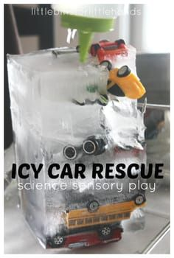
11:15-11:45 | Special -Library  PK.ELAL.20. [PKSL.2] Interacts with diverse formats and texts | Please see Miss D’s Class page https://librariansaintpete.wixsite.com/library
11:45-12:15 | Math-  Elephant and Piggie Number Mats  or Color the Graph  Standard: PK.MATH.3. Understands the relationship between numbers and quantities to 10, connects counting to cardinality  PK.MATH.3a. When counting objects, says the number names in the standard order, pairing each object with one and only one number name and each number name with one and only one object (1:1 correspondence)  PK.MATH.11. Sorts objects and shapes into categories; counts the objects in each category. | Elephant and Piggie Plahdoh Number Mats 1-10  or  Color the Graph  (See PDFs on Google Classroom)
12:15-1:00 | Lunch  PK.PDH.8. Demonstrates awareness and understanding of healthy habits | Your child can assist you in setting the table, getting the necessary items out to make lunch. (bread, cold cuts, P.B., jelly, milk, plates, napkins, cups)
1:00-1:45 | Recess  PK.PDH.6. Engages in a variety of physical fitness activities | Relay race, red light green light, free play outside
1:45-2:00 | Story of choice /discuss what you learned today and what you enjoyed doing. Rest and relax!  Standard: PKELA.20. {PKSL.2.} Interacts with diverse formats and texts (Shared read alouds, video clips, oral storytelling)  PKELA.22.{PKSL.4} Describes familiar people, places, things and events | Sample Questions: What was your favorite part of today? What did you enjoy the most?  Name one thing that you learned today?  REST TIME Music  https://www.youtube.com/watch?v=Lp6XlsBm_Lw

Date: Friday, 6/12
TIME | SUBJECT | RESOURCES
8:00-8:30 | Songs, calendar, weather, days of the week, letter of the week, go over the daily schedule. Talk about the day's activities.  QOTD: What can you use to make sound?  PK.SEL.6. Understands and follows routines and rules  PK.SOC.6. Develops an understanding of how people and things change over time and how to relate past events to their present and future activities  PK.SCI.8. [P-ESS2-1.] Asks questions, makes observations, and collects and records data using simple instruments to recognize patterns about how local weather conditions change daily and seasonally. | "12 Months" by The Laurie Berkner Band  https://www.youtube.com/watch?v=_Qv58l5o6ew  Weather Song  https://safeYouTube.net/w/BpgK
8:30-9:00 | Value of the Month: Friendship  Forever Friends  Standard: PK.SEL.4. Develops positive relationships with their peers  PK.SEL.4.b Interacts with other children (e.g. in play, conversation, etc.)  PK.SEL.4.e Develops friendship with one or more peers | Listen to and sing along with “Forever Friends” by Teresa Jennings.  https://safeYouTube.net/w/TxdK
9:00-9:30 | Puzzle, game of choice  PK.PDH.5. Demonstrates eye-hand coordination and fine motor skills
9:30-9:45 | Body Break  Standard: PK.ARTS.2 Performs Dance (A) Demonstrates basic full body movements (crawl, walk, run), non locomotor movements (bend, twist, reach) and spatial relationships (over, under, around) while moving in general space. | “Animals in Action” – Jack Hartmann  https://safeYouTube.net/w/VnfK  “Animal Dance and Freeze” – Jack Hartmann  https://safeYouTube.net/w/kpfK
9:45-10:30 | ELA - Read Aloud/Daily Name Writing/ Practice Writing letters  Daily Name Writing - First and last name  Read Aloud – Where the Wild Things Are by Maurice Sendak  Standard: PK.ELAL.4: Displays emergent reading behaviors with purpose and understanding  PK.ELAL.20: Interact with diverse formats and texts.  PK.PDH.5.a. Demonstrates ability to use fine motor skills (e.g. uses materials such as blunt scissors effectively) | Where the Wild Things Are by Maurice Sendak  https://safeYouTube.net/w/i7fK  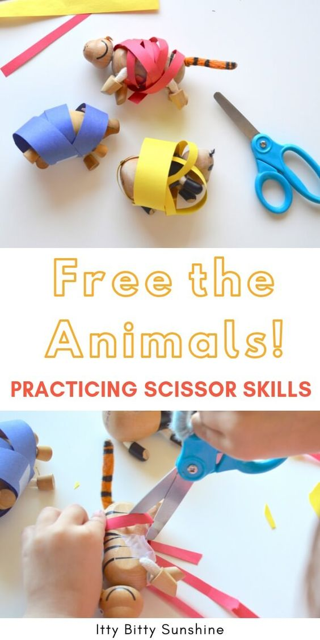  Free the Wild Animals!  Wrap dinosaur toys or animal figurines with strips of construction paper and a piece of tape.  Use scissors to cut the tape and free them –  Great scissors practice for Kindergarten! And FUN!
10:30-11:15 | Math-  Lego Duplo Animals  Standard: PK.MATH.15 Creates and builds shapes from components (e.g. sticks, blocks, clay) | Lego Duplo Bricks of different colors and shapes  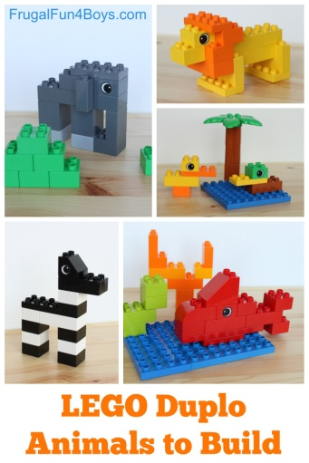  This website has more information and step by step directions, but also has A LOT of ads on the page.  https://frugalfun4boys.com/lego-duplo-animals-to-build/
11:15-11:45 | Special - Show and Tell  PK.AC.1. Demonstrates motivation to communicate  PK.AC.2. Demonstrates they are building background knowledge | Find an item to share with your family that has different colors, or makes sound.
11:45-12:15 | Science/ Social studies  Making Sound  PK.SCI.3 Plans and Conducts investigations to provide evidence that sound is produced by vibrating materials  PK.SCI.3a. Investigates vibrating materials such as percussion instruments (e.g., drum, triangle), string instruments (e.g., guitar, piano), wind instruments (e.g., recorder, whistle), and audio speakers | Making Sound  Materials you have around the house that make sound  (Musical instruments like drum, xylophone, guitar, keyboard/piano, whistle, everyday objects like a metal slinky, ruler, or kitchen items like colander and wooden spoon, bundt pan and whisk, muffin tin and teaspoon)  Test out different ways to make sound.  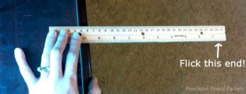  Talk about what your hands feel like after you start the sound on the instrument. Does hitting the colander with the wooden spoon also make your hand shake?  Explain: Sound moves in waves and when you start the sound, it moves through the instrument and that instrument sometimes moves your hands. Sound is made by vibrating materials. Sound also travels in waves up to our ears when we hear the sound!
12:15-1:00 | Lunch  PK.PDH.8. Demonstrates awareness and understanding of healthy habits | Your child can assist you in setting the table, getting the necessary items out to make lunch. (bread, cold cuts, P.B., jelly, milk, plates, napkins, cups)
1:00-1:45 | Recess  PK.PDH.6. Engages in a variety of physical fitness activities | Relay race, red light green light, free play outside
1:45-2:00 | Story of choice /discuss what you learned today and what you enjoyed doing. Rest and relax!  Standard: PK.ELAL.20. {PKSL.2.} Interacts with diverse formats and texts (Shared read alouds, video clips, oral storytelling)  PK.ELAL.22.{PKSL.4} Describes familiar people, places, things and events | Sample Questions: What was your favorite part of today? What did you enjoy the most?  Name one thing that you learned today?  REST TIME Music  https://www.youtube.com/watch?v=Lp6XlsBm_Lw

