At Home Learning Schedule for UPK
Date: Mon. 6/1
TIME | SUBJECT | RESOURCES
8:00-8:30 | Songs, calendar, weather, days of the week, letter of the week, go over the daily schedule. Talk about the day's activities.  QOTD: What gives us light, warms us, and helps plants and trees make food?  PK.SEL.6. Understands and follows routines and rules  PK.SOC.6. Develops an understanding of how people and things change over time and how to relate past events to their present and future activities  PK.MATH.1 Count up to 20 | "12 Months" by The Laurie Berkner Band  https://www.youtube.com/watch?v=_Qv58l5o6ew  What’s the Weather Like Today?  https://safeYouTube.net/w/0L1I  The Letter S Song  ABC Mouse.com “Tree Study – Week 5 playlist”
8:30-9:00 | Value of the Month: Friendship  Flat Mrs. Brands  PK.SEL.3 Demonstrates and continues to develop positive relationships with significant adults (primary caregivers, teachers, and other familiar adults) | Flat Mrs. Brands  Choose an activity from this week and take a picture of you and the photo cutout of Mrs. Brands (a.k.a. “Flat Mrs. Brands”) enjoying the activity together.
9:00-9:30 | Puzzle, game of choice  PK.PDH.5. Demonstrates eye-hand coordination and fine motor skills
9:30-9:45 | Body Break  Standard: PK.PDH.3.b. Maintains balance during sitting, standing, and movement activities | Mr. Golden Sun – Jack Hartmann  https://safeYouTube.net/w/CB1I  Good Morning Song  https://www.youtube.com/watch?v=3jPsradyuyI
9:45-10:30 | ELA - Read Aloud/Daily Name Writing/ Practice Writing letters  Daily Name Writing - First and last name  Read aloud- Sun by Susan Canizares  Standard: PK.ELAL.20: Interact with diverse formats and texts.  PK.ELAL.6 Retells stories or shares information from a text  PK.ELAL.12 Makes connections between self, text, and the world | Sun by Susan Canizares  Talk about 2 ways the sun helps plants and trees.  Then, talk about what the sun does for you, or how the sun makes you feel.  What animals have you seen in the sun?
10:30-11:15 | Math-  Sunny or Cold?  Standard: PK.MATH.6 Recognizes whether the number of objects in a group is more than, fewer than, or equal to (the same as) the number of objects in another group  PK.MATH.11 Sorts objects and shapes into categories; counts the objects in each category | Sunny or Cold?  Gather a bunch of items from your closet that you wear or use in summer or winter (or fall if your winter items are stored out of reach).  Some examples are: sunglasses, jacket, gloves, t-shirt, long pants, baseball cap, scarf, shorts, boots, and sunscreen.  Have your child sort the items into 2 groups: Clothes we wear when it’s Sunny, and clothes we wear when it’s cold.  Then, have him/her count how many objects in each group.  Ask: Which group has more objects?  Challenge: Ask specific questions like: Which group has fewer objects that you wear on your head?  Which group has more objects that cover your knees?
11:15-11:45 | Special - Music  PK.ARTS.9. [MU:Pr4-6.PK] Performs Music | Please see Mrs. Arco’s Class page http://arcomusicinstruction.weebly.com/
11:45-12:15 | Science/ Social studies  Playing with Shadows!  Standard: PK.SCI.9 Plans and conducts and investigation to determine the effect of sunlight on Earth’s surface.  PK.SCI.9a Discusses the effects of the sun (e.g. provides light, creates shadows, warms people, animals, plants) | Choose 1 Shadow Experiment to have fun with! (Depending on today’s weather, I gave an inside option in case it is too cloudy to see your shadow clearly).  Human Sundial  Materials: Sidewalk or Driveway (choose a wide-open spot that will be sunny all day) (Choose one that gets sun throughout the day)  Chalk  Sun (if it is too cloudy, you won’t see a clear shadow)  1. Mark a letter X where your child will stand every time.  2. Early in the morning, trace their shadow with chalk.  3. Go outside again about an hour or two later. Have your child stand on the letter x while you trace your child’s shadow with a different color of chalk.  4. Go outside before lunch or right after lunch, and trace your child’s shadow in a new color.  5. Later in the afternoon, go outside again to trace your child’s shadow in a different chalk color.  6. Talk about what your child notices about each tracing. Ask questions like “Which shadow looks tall?,” “Which shadow looks small?,” “Which shadow is closest to the grass?” “…front door?”  *Mrs. Brands would LOVE if you can share a picture and what your child said about this activity!  For more information, see: https://rhythmsofplay.com/human-sundial-shadow-science-experiment/  Shadow Art  This could be done as its own activity, or after doing the “Human Sundial”  “Chalk Paint” (crush up a broken piece of chalk into a powder, put it into one part of a muffin tin/empty plastic yogurt cups, and add a very small amount of water, mix it with a paint brush)  Paintbrush  Use the “Chalk Paint” and Paintbrush to decorate your shadow.  For more information, see: https://rhythmsofplay.com/recycled-chalk-paint/  Shadow Frame (This can be done inside with a flashlight and paper if the weather is cloudy or rainy.)  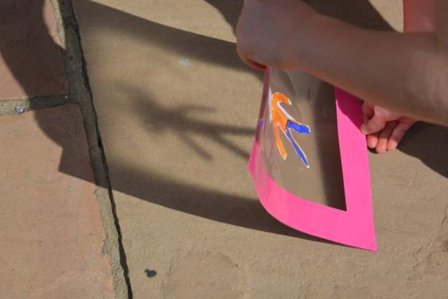  Create a shape on construction paper (person, cloud with rain, animal, heart, star, anything you like to draw)  Cut a frame out of cardboard or construction paper.  Cover one side of the frame with contact paper (or use waxed paper and tape, or the waxy bag inside a cereal box and tape). Place or tape your shape in the middle of the contact paper/wax paper.  Place another sheet of contact paper on top of the first sheet to seal your shape in the middle.  Take it outside to hold it in the sun and see the shadow on the ground, or use a flashlight and a white or yellow paper underneath. *Have a helper hold the flashlight while your child holds their Shadow Frame.  Talk about what you see.
12:15-1:00 | Lunch -  PK.PDH.8. Demonstrates awareness and understanding of healthy habits | Your child can assist you in setting the table, getting the necessary items out to make lunch. (bread, cold cuts, P.B., jelly, milk, plates, napkins, cups)
1:00-1:45 | Recess  PK.PDH.6. Engages in a variety of physical fitness activities | Relay race, red light green light, free play outside
1:45-2:00 | Story of choice /discuss what you learned today and what you enjoyed doing. Rest and relax!  PK.ELAL.22. [PKSL.4] Describes familiar people, places, things and events  PK.ELAL.24. [PKSL.6] Expresses thoughts, feelings, and ideas | Sample Questions: What was your favorite part of today? What did you enjoy the most?  Name one thing that you learned today?  REST TIME Music  https://www.youtube.com/watch?v=Lp6XlsBm_Lw
Date: Tuesday, 6/2
TIME | SUBJECT | RESOURCES
8:00-8:30 | Songs, calendar, weather, days of the week, letter of the week, go over the daily schedule. Talk about the day's activities.  QOTD: What are 2 forms of water?  PK.SEL.6. Understands and follows routines and rules  PK.SOC.6. Develops an understanding of how people and things change over time and how to relate past events to their present and future activities | Counting to 100  https://www.youtube.com/watch?v=0TgLtF3PMOc  Days Of The Week Addams Family (Parody) | Fun songs for Big Kids, Preschoolers and Toddlers  https://www.youtube.com/watch?v=8GKmCQOy88Y  You can clap if you cannot snap!
8:30-9:00 | Value of the Month: Friendship  Flat Mrs. Brands  PK.SEL.3 Demonstrates and continues to develop positive relationships with significant adults (primary caregivers, teachers, and other familiar adults) | Flat Mrs. Brands  Choose an activity from this week and take a picture of you and the photo cutout of Mrs. Brands (a.k.a. “Flat Mrs. Brands”) enjoying the activity together.
9:00-9:30 | Puzzle, game of choice  PK.PDH.5. Demonstrates eye-hand coordination and fine motor skills
9:30-9:45 | Body Break  Standard: PK.ARTS.2 Performs Dance (A) Demonstrates basic full body movements (crawl, walk, run), non locomotor movements (bend, twist, reach) and spatial relationships (over, under, around) while moving in general space. | Water Cycle with Blazer Fresh from GoNoodle  https://safeYouTube.net/w/dM1I  “The Goldfish (Let’s Go Swimming)” – Laurie Berkner Band  https://safeYouTube.net/w/bV1I  Poppin-Bubbles – Chamionverse –GoNoodle  https://www.youtube.com/watch?v=JdBlXPWM8AI
9:45-10:30 | ELA - Read Aloud/Daily Name Writing/ Practice Writing letters  Read Aloud – Water by Susan Canizares  Letter Squirt  Standard: PKELA.1.d Recognizes and names some upper/lowercase letters of the alphabet, especially those in one’s own name.  PK.ELAL.20: Interact with diverse formats and texts.  PK.ELAL.4: Displays emergent reading behaviors with purpose and understanding | Water by Susan Canizares and “We Use Water Everyday” Poster shared by Mrs. Brands  Letter Squirt  Write a few letters with marker on Ping pong balls (or plastic eggs, whatever you have available).  You can focus on the letters in your child’s name, or a few alphabet letters that are less familiar.  The photo above has Styrofoam and golf tees for the ping pong balls to rest on.  Fill a water gun with water.  Have your child use the water gun to knock the ball off of the tee.  Then, hold up the ball and ask him/her to name the letter or sound of the letter that was on the ping pong ball.  OR  Use a squirt bottle filled with water.  Write letters on a chalkboard or sidewalk in chalk.  Have your child name the letter or sound of the letter.  Then, squirt the letter until it disappears!  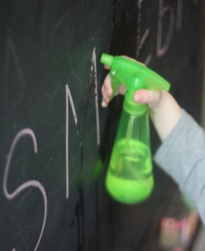
10:30-11:15 | Math-  Splish Splash Water Math  Standard: MATH.10. Identifies measurable attributes of objects, such as length or weight, and describes them using appropriate vocabulary (e.g., empty, full, heavy, light) | 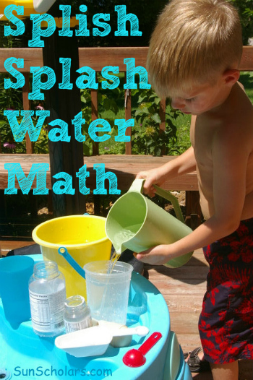  Kiddie Pool or Big Bucket  Containers and Cups of Various Sizes and Shapes  Water  1. Compare two containers to decide which holds more and which holds less.  2. How many of the smallest container will fit inside the largest container?  3. Fill two containers and ask “Which one feels heavy?” “Which one feels light?”
11:15-11:45 | Special - Music  PK.ARTS.9. [MU:Pr4-6.PK] Performs Music | Please see Mrs. Arco’s Class page http://arcomusicinstruction.weebly.com/
11:45-12:15 | Science/ Social studies  What Melts in the Sun  or  Ice Block  Standard: PK.SCI.1.a Observes and describes similarities and differences between solids and liquids based on their physical properties | What Melts in the Sun  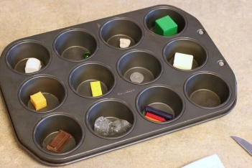  Muffin Tin (metal conducts the heat to help things melt)  Look at what you have around the house and let your child(ren) choose objects they think will melt  6 – 12 small objects such as Lego, ice cube, wooden block, butter, rock, cube of cheese, marble, quarter, chocolate square, a cube cut off a bar of soap, and three crayons (if you are okay cleaning this up afterwards)  Timer  Fill the muffin tin with one object in each cup. Set it out in the sun.  While you are waiting, you could fill out the observation sheet together.  Set a timer for 10 minutes, and then come back to check on the results.  https://frugalfun4boys.com/simple-science-experiment-for-kids-what-melts-in-the-sun/  Ice Blocks (This one might take 1 day to make and the  next day you can have fun melting it.)  Milk carton or plastic food container  Water  Small Toys (lego, plastic animals, cars)  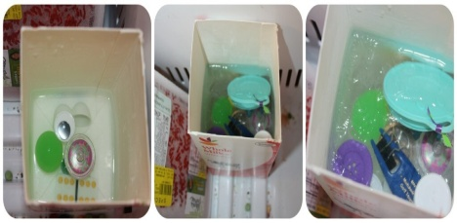  Sequins or Gems  1.) Put a bit of water in the bottom and add 3 toys.  2.) Set the container in the freezer to freeze that layer.  3.) A few hours later, add more water and more toys to the second layer.  4.) Set it back in the freezer. Repeat steps 3 and 4 until your container is as full as you want it, or has as many toys and gems as you want.  https://littlebinsforlittlehands.com/20-melting-ice-science-sensory-play-activities/
12:15-1:00 | Lunch  PK.PDH.8. Demonstrates awareness and understanding of healthy habits | Your child can assist you in setting the table, getting the necessary items out to make lunch. (bread, cold cuts, P.B., jelly, milk, plates, napkins, cups)
1:00-1:45 | Recess  PK.PDH.6. Engages in a variety of physical fitness activities | Relay race, red light green light, free play outside
1:45-2:00 | Story of choice /discuss what you learned today and what you enjoyed doing. Rest and relax!  PK.ELAL.22. [PKSL.4] Describes familiar people, places, things and events  PK.ELAL.24. [PKSL.6] Expresses thoughts, feelings, and ideas | Sample Questions: What was your favorite part of today? What did you enjoy the most?  Name one thing that you learned today?  REST TIME Music  https://www.youtube.com/watch?v=Lp6XlsBm_Lw

Date: Wednesday, 6/3
TIME | SUBJECT | RESOURCES
8:00-8:30 | Songs, calendar, weather, days of the week, letter of the week, go over the daily schedule. Talk about the day's activities.  QOTD: What do plants need to grow?  PK.SEL.6. Understands and follows routines and rules  PK.SCI.8. Asks questions, makes observations, and collects and records data using simple instruments to recognize patterns about how local weather conditions change daily and seasonally. | Days of week  https://www.youtube.com/watch?v=Oiisv7EhG98  A Little Seed  https://safeYouTube.net/w/OI1I  The Needs of a Plant  https://safeYouTube.net/w/oQ1I
8:30-9:00 | Value of the Month: Friendship  Standard: PK.SEL.4. Develops positive relationships with their peers  PK.SEL.4.b Interacts with other children (e.g. in play, conversation, etc.)  PK.SEL.4.e Develops friendship with one or more peers | Circle Time on Zoom  We will be making a snack together today!  We are also celebrating one friend’s June birthday.
9:00-9:30 | Puzzle, game of choice  PK.PDH.5. Demonstrates eye-hand coordination and fine motor skills
9:30-9:45 | Body Break  Standard: PK.ARTS.2 Performs Dance (A) Demonstrates basic full body movements (crawl, walk, run), non locomotor movements (bend, twist, reach) and spatial relationships (over, under, around) while moving in general space. | Let’s Move - Jack Hartman  https://safeYouTube.net/w/zO1I  “My Energy” by The Laurie Berkner Band https://www.youtube.com/watch?v=qKcs_oefYyk  “I Get Loose” – Koo Koo Kanga Roo by GoNoodle  https://www.youtube.com/watch?v=if8qfVjVFc8
9:45-10:30 | ELA - Read Aloud/Daily Name Writing/ Practice Writing letters  Read Aloud – The Carrot Seed by Ruth Krauss  Standard: PK.ELAL.4: Displays emergent reading behaviors with purpose and understanding  PK.SCI.5 Plans and Conducts investigations to determine how familiar plants use their external parts to help them survive in the environment. | The Carrot Seed by Ruth Krauss  https://safeYouTube.net/w/of2I  What Plants Need craft  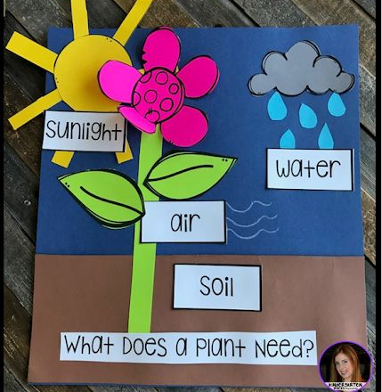
10:30-11:15 | Math-  “Carrot Math”  Standard: PK.MATH.2 Represents a number of objects (0-5), with a written numeral 0-5  PK.MATH.4. Given a number from 1-10, counts out that many objects | Carrot Math  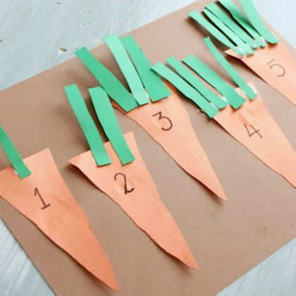  Construction Paper  brown paper  5 orange triangles for carrots  15 green strips  scissors, glue  Have your child trace or write 1-5 on the carrots.  Then, have your child count the green strips of paper and glue that number of leaves on each carrot.
11:15-11:45 | Please visit Coach L’s Google Classroom. | Visit Coach L.’s Google Classroom to check out fun new workout videos!  Fill out your Fitness Tracker and send it to Coach L.
11:45-12:15 | Science/ Social studies-  What are Plants?  Standard: PK.SCI.6.a Observes and represents familiar plants (e.g. draws pictures, builds a model)  PK.ELAL.22. [PKSL.4] Describes familiar people, places, things and events  PK.ARTS.16.a Engages in self-directed imaginative play with a variety of materials and/or art-making tools  PK.ELAL.23. [PKSL.5] Creates a visual display (e.g., drawing, art work, building, writing) | Watch “What are Plants” from Scholastic Classroom Magazine  https://watchandlearn.scholastic.com/videos/animals-and-plants/plants/what-are-plants.html  Talk about what plants need to grow.  Share your ideas with Mrs. Brands on Google Classroom or by e-mail.
12:15-1:00 | Lunch  PK.PDH.8. Demonstrates awareness and understanding of healthy habits | Your child can assist you in setting the table, getting the necessary items out to make lunch. (bread, cold cuts, P.B., jelly, milk, plates, napkins, cups)
1:00-1:45 | Recess  PK.PDH.6. Engages in a variety of physical fitness activities | Relay race, red light green light, free play outside
1:45-2:00 | Story of choice /discuss what you learned today and what you enjoyed doing. Rest and relax!  Standard: PKELA.20. {PKSL.2.} Interacts with diverse formats and texts (Shared read alouds, video clips, oral storytelling)  PKELA.22.{PKSL.4} Describes familiar people, places, things and events | Sample Questions: What was your favorite part of today? What did you enjoy the most?  Name one thing that you learned today?  REST TIME Music  https://www.youtube.com/watch?v=Lp6XlsBm_Lw

Date: Thursday 6/4
TIME | SUBJECT | RESOURCES
8:00-8:30 | Songs, calendar, weather, days of the week, letter of the week, go over the daily schedule. Talk about the day's activities.  How do trees look different in the Spring than in the Winter?  PK.SEL.6. Understands and follows routines and rules  PK.SOC.6. Develops an understanding of how people and things change over time and how to relate past events to their present and future activities  PK.SCI.8. [P-ESS2-1.] Asks questions, makes observations, and collects and records data using simple instruments to recognize patterns about how local weather conditions change daily and seasonally. | 12 Months of the Year Jack Hartmann  https://www.youtube.com/watch?v=omkuE6Wa5kQ  Days Of The Week Addams Family (Parody) | Fun songs for Big Kids, Preschoolers and Toddlers  https://www.youtube.com/watch?v=8GKmCQOy88Y  You can clap if you cannot snap!
8:30-9:00 | Value of the Month: Friendship  Standard: PK.SEL.4.e Develops friendship with one or more peers  PK.SEL.4.b Interacts with other children (e.g. in play, conversation, etc.) | Choose 1 Activity:  - Draw a picture for a friend.  - Leave a nice note in a Library book.  - Do a chore for someone at home.
9:00-9:30 | Puzzle, game of choice  PK.PDH.5. Demonstrates eye-hand coordination and fine motor skills
9:30-9:45 | Body Break  Standard: PK.ARTS.2 Performs Dance (A) Demonstrates basic full body movements (crawl, walk, run), non locomotor movements (bend, twist, reach) and spatial relationships (over, under, around) while moving in general space. | “If You Feel It” Seasonal Songs in Motion – The Learning Station  https://safeYouTube.net/w/nR1I  “Shake Something” by Hap Palmer  https://safeYouTube.net/w/eT1I  This is My Trunk. I’m a Tall, Tall Tree!  https://safeYouTube.net/w/MS1I
9:45-10:30 | ELA - Read Aloud/Daily Name Writing/ Practice Writing letters  Read Aloud –  “Backyard Science:Trees” by Harold Morris (ABC Mouse.com)  Standard: PKELA.1.1 Demonstrates understanding of the organization and basic features of print.(D) recognizes and names some upper/lowercase letters of the alphabet, especially those in one’s own name. | “Backyard Science:Trees” by Harold Morris  1. Log in to abcmouse.com/login  2. Click on your child’s picture.  3. Click on “About Me.”  4. Click on “My Lessons.”  5. Open the playlist called "Tree Study – Week 5”  6. Read “Backyard Science:Trees” by Harold Morris together.
10:30-11:15 | Science/ Social studies  Trees in Different Seasons  Standard: PK.ELAL.22. [PKSL.4] Describes familiar people, places, things and events  PK.ELAL.23. [PKSL.5] Creates a visual display (e.g., art work)  PK.SCI.6.a Observes and represents familiar plants (e.g. draws pictures) | Listen to Mrs. Brands read “Apple Trees’ by Gail Saunders-Smith  Spring Tree Craft Dr. Jean (See Google Classroom for directions)
11:15-11:45 | Special -Library  PK.ELAL.20. [PKSL.2] Interacts with diverse formats and texts | Please see Miss D’s Class page https://librariansaintpete.wixsite.com/library
11:45-12:15 | Math-  Make a Pattern  PK.MATH.9 Duplicates and extends simple patterns using concrete objects | Trees change in the same way from one season to another, like a pattern. The tree pattern from Spring to Winter would be: Trees grow flowers, Leaves are green, Leaves change color, Trees are bare, and then the pattern repeats again.  Use the Learning Links to Make a Pattern  Level 1: Basic Two-Part Pattern: Red, Blue  Level 2: Three Part Pattern: Blue, Yellow, Red or Four Part Pattern: Blue, Yellow, Red, Green  Level 3: Challenge: You make a pattern, and your child has to recreate the pattern you made.
12:15-1:00 | Lunch  PK.PDH.8. Demonstrates awareness and understanding of healthy habits | Your child can assist you in setting the table, getting the necessary items out to make lunch. (bread, cold cuts, P.B., jelly, milk, plates, napkins, cups)
1:00-1:45 | Recess  PK.PDH.6. Engages in a variety of physical fitness activities | Relay race, red light green light, free play outside
1:45-2:00 | Story of choice /discuss what you learned today and what you enjoyed doing. Rest and relax!  Standard: PKELA.20. {PKSL.2.} Interacts with diverse formats and texts (Shared read alouds, video clips, oral storytelling)  PKELA.22.{PKSL.4} Describes familiar people, places, things and events | Sample Questions: What was your favorite part of today? What did you enjoy the most?  Name one thing that you learned today?  REST TIME Music  https://www.youtube.com/watch?v=Lp6XlsBm_Lw

Date: Friday, 6/5
TIME | SUBJECT | RESOURCES
8:00-8:30 | Songs, calendar, weather, days of the week, letter of the week, go over the daily schedule. Talk about the day's activities.  QOTD: What did you learn about trees during our Tree Study?  PK.SEL.6. Understands and follows routines and rules  PK.SOC.6. Develops an understanding of how people and things change over time and how to relate past events to their present and future activities  PK.SCI.8. [P-ESS2-1.] Asks questions, makes observations, and collects and records data using simple instruments to recognize patterns about how local weather conditions change daily and seasonally. | Sesame Street: Usher's ABC Song  https://www.youtube.com/watch?v=SWvBAQf7v8g  "12 Months" by The Laurie Berkner Band  https://www.youtube.com/watch?v=_Qv58l5o6ew
8:30-9:00 | Value of the Month: Friendship  Standard: PK.SEL.4. Develops positive relationships with their peers  PK.SEL.4.b Interacts with other children (e.g. in play, conversation, etc.)  PK.SEL.4.e Develops friendship with one or more peers | Use crayons and markers to color the Friendship coloring page.
9:00-9:30 | Puzzle, game of choice  PK.PDH.5. Demonstrates eye-hand coordination and fine motor skills
9:30-9:45 | Body Break  Standard: PK.ARTS.2 Performs Dance (A) Demonstrates basic full body movements (crawl, walk, run), non locomotor movements (bend, twist, reach) and spatial relationships (over, under, around) while moving in general space. | I Can Move My Body Like Anything  https://www.youtube.com/watch?v=oLaJ4jyKBUY  Spring is Here –The Learning Station  https://safeYouTube.net/w/0p4I  “We Are the Dinosaurs” by Laurie Berkner  https://www.youtube.com/watch?v=vPrmY7labLA
9:45-10:30 | ELA - Read Aloud/Daily Name Writing/ Practice Writing letters  Daily Name Writing - First and last name  Read Aloud – A Tree Can Be… by Judy Nayer  Standard: PKELA.1. Demonstrates understanding of the organization and basic features of print.(D) recognizes and names some upper/lowercase letters of the alphabet, especially those in one’s own name. | A Tree Can Be… by Judy Nayer  Log in to Seesaw.me to view the activity called “K-W-L”  Fill out what you Learned about trees.  Follow the directions on Seesaw to “Add a Response” and click the green checkmark to save your work.
10:30-11:15 | Math-  Number Dice Match Up  or  Memory  Standard: PK.MATH.3. a When counting objects, says the number names in the standard order, pairing each object with one and only one number name and each number name with one and only one object. (1:1 Correspondence) | Number Dice Match Up: Write numbers 1–6 in one column, and draw the 6 dice faces in another. Then task your kids to match each number with the corresponding die.  OR  Memory: In this version, arrange an even number of paper plates on your driveway, then write pairs of numbers under them. Have you kids take turns flipping over 2 plates at a time to try to find a match.
11:15-11:45 | Special - Show and Tell  PK.AC.1. Demonstrates motivation to communicate  PK.AC.2. Demonstrates they are building background knowledge | Find an item to share with your family that is TALL or small.
11:45-12:15 | Science/ Social studies  Spring Trees  PK.ELAL.23. [PKSL.5] Creates a visual display  PK.SCI.5 Plans and Conducts investigations to determine how familiar plants use their external parts to help them survive in the environment. | Yesterday we saw pictures of Apple Trees in different seasons. Take a walk around your yard or your neighborhood and look for flower blossoms that grow on trees in the spring.  Try to look for different colors of blossoms or different shapes of blossoms growing on the trees. If you find a tree without blossoms, look at the leaves that are growing. What do you see about the leaves?
12:15-1:00 | Lunch  PK.PDH.8. Demonstrates awareness and understanding of healthy habits | Your child can assist you in setting the table, getting the necessary items out to make lunch. (bread, cold cuts, P.B., jelly, milk, plates, napkins, cups)
1:00-1:45 | Recess  PK.PDH.6. Engages in a variety of physical fitness activities | Relay race, red light green light, free play outside
1:45-2:00 | Story of choice /discuss what you learned today and what you enjoyed doing. Rest and relax!  Standard: PK.ELAL.20. {PKSL.2.} Interacts with diverse formats and texts (Shared read alouds, video clips, oral storytelling)  PK.ELAL.22.{PKSL.4} Describes familiar people, places, things and events | Sample Questions: What was your favorite part of today? What did you enjoy the most?  Name one thing that you learned today?  REST TIME Music  https://www.youtube.com/watch?v=Lp6XlsBm_Lw

