At Home Learning Schedule for UPK
Date: Tuesday, 5/26
TIME | SUBJECT | RESOURCES
8:00-8:30 | Songs, calendar, weather, days of the week, letter of the week, go over the daily schedule. Talk about the day's activities.  QOTD: Does a pinecone grow on a tree?  PK.SEL.6. Understands and follows routines and rules  PK.SOC.6. Develops an understanding of how people and things change over time and how to relate past events to their present and future activities  PK.SCI.8. Asks questions, makes observations, and collects and records data using simple instruments to recognize patterns about how local weather conditions change daily and seasonally. | Counting to 100  https://safeYouTube.net/w/GOPG  The Bees go Buzzing  https://safeYouTube.net/w/2NPG
8:30-9:00 | Value of the Month: Kindness  Penguin and Pinecone  Standard: PKSEL.1.Regulates responses to needs, feelings and events. (A) Expresses feelings, needs, opinions and desires in a way that is appropriate to the situation.(D) Demonstrates an ability to independently modify behavior in different situations. | Listen to Penguin and Pinecone: a friendship story by Salina Yoon  https://safeYouTube.net/w/EgmH  The story begins at 1:25 on the video counter and ends at 4:25.  Talk about something that you and a friend did to grow your friendship. Think about your favorite game to play, activity to do, or something that was tricky at first, but you learned to do together.
9:00-9:30 | Puzzle, game of choice  PK.PDH.5. Demonstrates eye-hand coordination and fine motor skills
9:30-9:45 | Body Break  Standard: PK.ARTS.2 Performs Dance (A) Demonstrates basic full body movements (crawl, walk, run), non locomotor movements (bend, twist, reach) and spatial relationships (over, under, around) while moving in general space. | “Don’t Give Up” Bruno Mars  https://safeYouTube.net/w/5SPG  “Way Down Yonder” – The Learning Station  https://safeYouTube.net/w/9dSG  “Bee Breath” (Calm Down) – GoNoodle  https://safeYouTube.net/w/rvQG
9:45-10:30 | ELA - Read Aloud/Daily Name Writing/ Practice Writing letters  Read Aloud – Chicka Chicka 1, 2, 3 by Bill Martin Jr. and John Archambault  Standard: PK,ELA.1.d Recognizes and names some upper/lowercase letters of the alphabet, especially those in one’s own name.  PK.ELAL.20: Interact with diverse formats and texts.  PK.ELAL.4: Displays emergent reading behaviors with purpose and understanding | 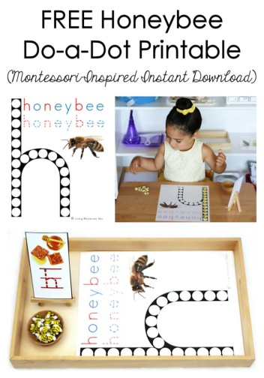  Honeybee-Do-a-Dot-Printable_LivingMontessoriNOW  Use a yellow dabber  Or put bubble wrap on top of a roller, tape it. Dip in yellow paint and paint over the “h” for a honeycomb effect!
10:30-11:15 | Math-  Number Sensory Bin  Standard: PK.MATH.2 Represents a number of objects (0-5), with a written numeral 0-5 (Students can select the corresponding number.) | Place magnetic numbers (or foam numbers, whatever you have) in a plastic bin or mixing bowl.  Cover them with uncooked rice, dried beans, sand, or cereal (whatever you have and are comfortable using)  Have your child use a plastic cup or hands to dig out the numbers.  Then, place each number he/she finds on the Number Hunt Sheet.
11:15-11:45 | Special - Music  PK.ARTS.9. [MU:Pr4-6.PK] Performs Music | Please see Mrs. Arco’s Class page http://arcomusicinstruction.weebly.com/
11:45-12:15 | Science/ Social studies  Standard: PK.SCI.4.a Explores what a variety of living organisms need to live and grow (water, nutrients, environment)  PK.ELAL.23 Creates a visual display (e.g. drawing, art work, building, writing) | 1. Log in to abcmouse.com/login  2. Click on your child’s picture.  3. Click on “About Me.”  4. Click on “My Lessons.”  5. Open the playlist called "Tree Study Week 4”  6. Have your child listen to “Honey Bees.” The book goes into great detail at points. The key ideas are on pages 8, 9, 16, 18 and 19.  Toilet Paper Roll Bee Craft for Kids  https://www.easypeasyandfun.com/paper-roll-bee-craft-for-kids/  OR  Bee finger puppet  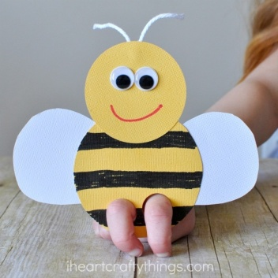  https://iheartcraftythings.com/bee-finger-puppets-craft.html
12:15-1:00 | Lunch  PK.PDH.8. Demonstrates awareness and understanding of healthy habits | Your child can assist you in setting the table, getting the necessary items out to make lunch. (bread, cold cuts, P.B., jelly, milk, plates, napkins, cups)
1:00-1:45 | Recess  PK.PDH.6. Engages in a variety of physical fitness activities | Relay race, red light green light, free play outside
1:45-2:00 | Story of choice /discuss what you learned today and what you enjoyed doing. Rest and relax!  PK.ELAL.22. [PKSL.4] Describes familiar people, places, things and events  PK.ELAL.24. [PKSL.6] Expresses thoughts, feelings, and ideas | Sample Questions: What was your favorite part of today? What did you enjoy the most?  Name one thing that you learned today?  REST TIME Music  https://www.youtube.com/watch?v=Lp6XlsBm_Lw

Date: Wednesday, 5/27
TIME | SUBJECT | RESOURCES
8:00-8:30 | Songs, calendar, weather, days of the week, letter of the week, go over the daily schedule. Talk about the day's activities.  QOTD: Does a walnut grow on a tree?  PK.SEL.6. Understands and follows routines and rules  PK.SCI.8. Asks questions, makes observations, and collects and records data using simple instruments to recognize patterns about how local weather conditions change daily and seasonally. | "12 Months" by The Laurie Berkner Band  https://www.youtube.com/watch?v=_Qv58l5o6ew  Days of week  https://www.youtube.com/watch?v=Oiisv7EhG98  See it, Say it, Sign it Letter Sounds  https://safeYouTube.net/w/wAPG
8:30-9:00 | Flat Mrs. Brands  Standard: PK.SEL.3. Demonstrates and continues to develop positive relationships with significant adults (primary caregivers, teachers, and other familiar adults) | In your backpack last week, you were given a “Flat Mrs. Brands” (like the book Flat Stanley).  Choose an activity from today and take a picture of you and the photo cutout of Mrs. Brands (a.k.a. “Flat Mrs. Brands”) enjoying the activity together.
9:00-9:30 | Puzzle, game of choice  PK.PDH.5. Demonstrates eye-hand coordination and fine motor skills
9:30-9:45 | Body Break  Standard: PK.ARTS.2 Performs Dance (A) Demonstrates basic full body movements (crawl, walk, run), non locomotor movements (bend, twist, reach) and spatial relationships (over, under, around) while moving in general space. | “A Tree Song” Action Dance  https://safeYouTube.net/w/fLPG  “Tony Chestnut” The Learning Station (slow, then fast)  https://safeYouTube.net/w/W3QG  “My Energy” by The Laurie Berkner Band https://www.youtube.com/watch?v=qKcs_oefYyk
9:45-10:30 | ELA - Read Aloud/Daily Name Writing/ Practice Writing letters  Read Aloud – Trees Count by Trish Holland  Standard: PK,ELA.1.d Recognizes and names some upper/lowercase letters of the alphabet, especially those in one’s own name.  PK.ELAL.20: Interact with diverse formats and texts.  PK.ELAL.4: Displays emergent reading behaviors with purpose and understanding | Listen to Trees Count by Trish Holland read aloud by Mrs. Brands  Help Amos Find his way back to his Nest  walnut- and acorn-shaped papers with letters written on them (or you could print some on the computer, or use letter pads if you have a game at home that has them)  1.) Scatter the letters across the floor.  2.) Call out a letter sound.  3.) Have your child(ren) hop/scurry/crawl to the  letter that makes that sound.  4.) Choose a new sound to call out.  * For multiple players, give each child his/her own sound to move over to.
10:30-11:15 | Math-  “Chicka Chicka 1, 2, 3, Can you build an Apple Tree?”  Standard: PK.MATH.2 Represents a number of objects (0-5), with a written numeral 0-5 (Students can select the corresponding number.)  PK.MATH.3 Understands the relationship between numbers and quantities to 10, connects counting to cardinality | Log in to Seesaw.me to view the activity called “Chicka Chicka 1, 2, 3, Can you build an Apple Tree? for 5/27”  Follow the directions on Seesaw to “Add a Response” and click the green checkmark to save your work.
11:15-11:45 | Please visit Coach L’s Google Classroom. | Visit Coach L.’s Google Classroom to check out fun new workout videos!  Fill out your Fitness Tracker and send it to Coach L.
11:45-12:15 | Science/ Social studies-  Trees  Standard: PK.SCI.6.a Observes and represents familiar plants (e.g. builds a model)  PK.ARTS.16.a Engages in self-directed imaginative play with a variety of materials and/or art-making tools  PK.ELAL.23. [PKSL.5] Creates a visual display (e.g., art work)  PK.PDH.8. Demonstrates awareness and understanding of healthy habits.  PK.PDH.8. Indicators:  a. Recognizes the importance of good nutrition, water, rest and sleep to be healthy | Wax Paper  Pretzels in different sizes (for the trunk, branches, and roots)  Grapes, or Cereal (for the leaves)  Your child will build their model of a tree using ingredients you have at home.  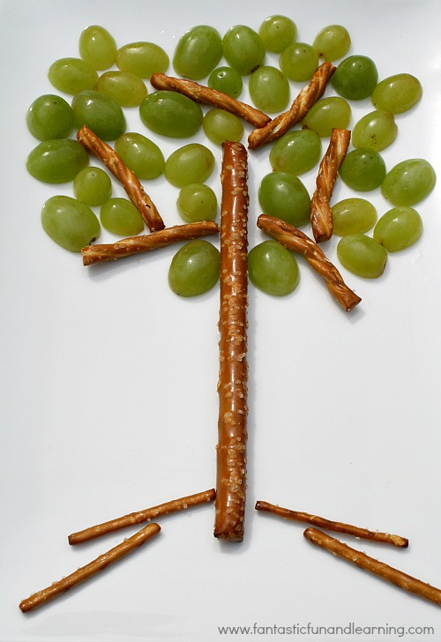  Talk about the parts of a tree as he or she builds.  Take a picture of your tree if you can to share with Mrs. Brands.  Enjoy this tasty “TREE-t”!
12:15-1:00 | Lunch  PK.PDH.8. Demonstrates awareness and understanding of healthy habits | Your child can assist you in setting the table, getting the necessary items out to make lunch. (bread, cold cuts, P.B., jelly, milk, plates, napkins, cups)
1:00-1:45 | Recess  PK.PDH.6. Engages in a variety of physical fitness activities | Relay race, red light green light, free play outside
1:45-2:00 | Story of choice /discuss what you learned today and what you enjoyed doing. Rest and relax!  Standard: PKELA.20. {PKSL.2.} Interacts with diverse formats and texts (Shared read alouds, video clips, oral storytelling)  PKELA.22.{PKSL.4} Describes familiar people, places, things and events | Sample Questions: What was your favorite part of today? What did you enjoy the most?  Name one thing that you learned today?  REST TIME Music  https://www.youtube.com/watch?v=Lp6XlsBm_Lw

Date: Thursday 5/28
TIME | SUBJECT | RESOURCES
8:00-8:30 | Songs, calendar, weather, days of the week, letter of the week, go over the daily schedule. Talk about the day's activities.  QOTD: Does an apple grow on a tree?  PK.SEL.6. Understands and follows routines and rules  PK.SOC.6. Develops an understanding of how people and things change over time and how to relate past events to their present and future activities  PK.SCI.8. [P-ESS2-1.] Asks questions, makes observations, and collects and records data using simple instruments to recognize patterns about how local weather conditions change daily and seasonally. | 12 Months of the Year Jack Hartmann  https://www.youtube.com/watch?v=omkuE6Wa5kQ  Days Of The Week Addams Family (Parody) | Fun songs for Big Kids, Preschoolers and Toddlers  https://www.youtube.com/watch?v=8GKmCQOy88Y  You can clap if you cannot snap!
8:30-9:00 | Value of the Month: Kindness  Standard: PKSEL.1.Regulates responses to needs, feelings and events. (A) Expresses feelings, needs, opinions and desires in a way that is appropriate to the situation.(D) Demonstrates an ability to independently modify behavior in different situations. | The Three Friends And the Apples by Tomie DePaola  Listen to the story.  Share your child’s response to: What do you like to do with your friends?
9:00-9:30 | Puzzle, game of choice  PK.PDH.5. Demonstrates eye-hand coordination and fine motor skills | “How Apples Grow Cutout Puzzle” on ABC Mouse.com
9:30-9:45 | Body Break  Standard: PK.ARTS.2 Performs Dance (A) Demonstrates basic full body movements (crawl, walk, run), non locomotor movements (bend, twist, reach) and spatial relationships (over, under, around) while moving in general space. | “Way Up High in an Apple Tree”  https://safeYouTube.net/w/Z6PG  “Shake Something” by Hap Palmer  https://www.youtube.com/watch?v=rDaa7Q2so-s
9:45-10:30 | ELA - Read Aloud/Daily Name Writing/ Practice Writing letters  Read Aloud – Pick Me An Apple: From Seed to Tree by Shelly Rotner  Standard: PK,ELA.1.d Recognizes and names some upper/lowercase letters of the alphabet, especially those in one’s own name.  PK.ELAL.20: Interact with diverse formats and texts.  PK.ELAL.4: Displays emergent reading behaviors with purpose and understanding | Listen to Pick Me An Apple: From Seed to Tree by Shelly Rotner read aloud by Mrs. Brands  Retell the steps of how an apple grows from seed to apple tree.
10:30-11:15 | Science/ Social studies  Standard: PK.ELAL.22. [PKSL.4] Describes familiar people, places, things and events  PK.ELAL.23. [PKSL.5] Creates a visual display (e.g., drawing, art work, building, writing)  PK.SCI.6.a Observes and represents familiar plants (e.g. draws pictures) | 1. Log in to abcmouse.com/login  2. Click on your child’s picture.  3. Click on “About Me.”  4. Click on “My Lessons.”  5. Open the playlist called "Tree Study – Week 4”  6. Have your child play “Professor Squirrel and Nutty: Plants Grow from Seeds”
11:15-11:45 | Special -Library  PK.ELAL.20. [PKSL.2] Interacts with diverse formats and texts | Please see Miss D’s Class page https://librariansaintpete.wixsite.com/library
11:45-12:15 | Math-  Adding Links  Standard: Understands addition as adding to, and understand subtraction as taking from  PK.MATH.8. Explores addition and subtraction by using objects and responding to real world situations (e.g., if we have 3 apples and add 2 more, how many apples do we have all together?) | Use the plastic links from the Lakeshore Learning backpack to add to.  I have 3 green links and add 1 blue link. How many links do I have now?  I have 2 yellow links and my friend has 4 red links. How many links do we have all together?  You could also give some examples of apples, and use the links to help solve it. “If we have 3 apples and add 2 more, how many apples do we have all together?”
12:15-1:00 | Lunch  PK.PDH.8. Demonstrates awareness and understanding of healthy habits | Your child can assist you in setting the table, getting the necessary items out to make lunch. (bread, cold cuts, P.B., jelly, milk, plates, napkins, cups)
1:00-1:45 | Recess  PK.PDH.6. Engages in a variety of physical fitness activities | Relay race, red light green light, free play outside
1:45-2:00 | Story of choice /discuss what you learned today and what you enjoyed doing. Rest and relax!  Standard: PKELA.20. {PKSL.2.} Interacts with diverse formats and texts (Shared read alouds, video clips, oral storytelling)  PKELA.22.{PKSL.4} Describes familiar people, places, things and events | Sample Questions: What was your favorite part of today? What did you enjoy the most?  Name one thing that you learned today?  REST TIME Music  https://www.youtube.com/watch?v=Lp6XlsBm_Lw

Date: Friday, 5/29
TIME | SUBJECT | RESOURCES
8:00-8:30 | Songs, calendar, weather, days of the week, letter of the week, go over the daily schedule. Talk about the day's activities.  QOTD: Which food tastes best to you,  avocados or apples ?  PK.SEL.6. Understands and follows routines and rules  PK.SOC.6. Develops an understanding of how people and things change over time and how to relate past events to their present and future activities  PK.SCI.8. [P-ESS2-1.] Asks questions, makes observations, and collects and records data using simple instruments to recognize patterns about how local weather conditions change daily and seasonally. | Sesame Street: Usher's ABC Song  https://www.youtube.com/watch?v=SWvBAQf7v8g  "12 Months" by The Laurie Berkner Band  https://www.youtube.com/watch?v=_Qv58l5o6ew  “Apples and Bananas” The Learning Station  https://safeYouTube.net/w/T4PG
8:30-9:00 | Flat Mrs. Brands  Standard: PK.SEL.3. Demonstrates and continues to develop positive relationships with significant adults (primary caregivers, teachers, and other familiar adults) | In your backpack last week, you were given a “Flat Mrs. Brands” (like the book Flat Stanley).  Choose an activity from today and take a picture of you and the photo cutout of Mrs. Brands (a.k.a. “Flat Mrs. Brands”) enjoying the activity together.
9:00-9:30 | Puzzle, game of choice  PK.PDH.5. Demonstrates eye-hand coordination and fine motor skills
9:30-9:45 | Body Break  Standard: PK.ARTS.2 Performs Dance (A) Demonstrates basic full body movements (crawl, walk, run), non locomotor movements (bend, twist, reach) and spatial relationships (over, under, around) while moving in general space. | The Best Tees (GoNoodle) – Guacamole  https://safeYouTube.net/w/vpQG  “We Are the Dinosaurs” by Laurie Berkner  https://www.youtube.com/watch?v=vPrmY7labLA
9:45-10:30 | ELA - Read Aloud/Daily Name Writing/ Practice Writing letters  Daily Name Writing - First and last name  Read Aloud – Harold and the Purple Crayon by Crockett Johnson  Standard: PKELA.1.d Recognizes and names some upper/lowercase letters of the alphabet, especially those in one’s own name.  PK.ELAL.20: Interact with diverse formats and texts.  PK.ELAL.4: Displays emergent reading behaviors with purpose and understanding | Listen to Harold and the Purple Crayon by Crockett Johnson read aloud by Mrs. Brands  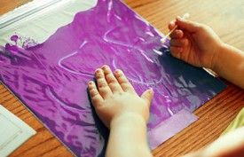  Plastic Ziploc Bag  Purple paint (or have your child mix blue and red)  a Q-tip or writing object that is soft  Fill a Ziploc bag with enough paint to spread (*make sure it is tightly sealed after adding paint)  Using the Q-tip, have your child draw a scene from the story and then tell you about it.
10:30-11:15 | Math-  “Chicka Chicka 1, 2, 3, Will there be a place for Me?”  Standard: PK.MATH.1 Counts to 20  PK.MATH.3 Understands the relationship between numbers and quantities to 10, connects counting to cardinality | Log in to Seesaw.me to view the activity called “Chicka Chicka 1, 2, 3, Will there be a place for Me? for 5/29”  Follow the directions on Seesaw to “Add a Response” and click the green checkmark to save your work.
11:15-11:45 | Special - Show and Tell  PK.AC.1. Demonstrates motivation to communicate  PK.AC.2. Demonstrates they are building background knowledge | Find an item to share with your family that grows on a tree, or is the shape of a tree.
11:45-12:15 | Science/ Social studies  Taco Stand  Standards: PK.ELAL.23. [PKSL.5] Creates a visual display  PK. PK.SOC.7. Develops a basic understanding of economic concepts within a community  PK.SOC.7. Indicators:  a. Recognizes that goods and services may be purchased using different forms of payment, (e.g., coins, paper money, checks, credit cards) | Taco Stand  Play food (or Playdoh)  Printable Menu and Order form (or paper and  markers)  Play money or game pieces  Choose a taco or burrito. Then, choose your toppings.  Decide if you want to add avocado to your taco.  Once you order, pay for your taco or burrito. You can use play money to count to 5, or use pieces from a board game as money.  Then, have the employee make your order with play food or Playdoh.  Switch roles and play again.
12:15-1:00 | Lunch  PK.PDH.8. Demonstrates awareness and understanding of healthy habits | Your child can assist you in setting the table, getting the necessary items out to make lunch. (bread, cold cuts, P.B., jelly, milk, plates, napkins, cups)
1:00-1:45 | Recess  PK.PDH.6. Engages in a variety of physical fitness activities | Relay race, red light green light, free play outside
1:45-2:00 | Story of choice /discuss what you learned today and what you enjoyed doing. Rest and relax!  Standard: PK.ELAL.20. {PKSL.2.} Interacts with diverse formats and texts (Shared read alouds, video clips, oral storytelling)  PK.ELAL.22.{PKSL.4} Describes familiar people, places, things and events | Sample Questions: What was your favorite part of today? What did you enjoy the most?  Name one thing that you learned today?  REST TIME Music  https://www.youtube.com/watch?v=Lp6XlsBm_Lw

