At Home Learning Schedule for UPK
Date: Monday, 4/20
TIME | SUBJECT | RESOURCES
8:00-8:30 | Songs, calendar, weather, days of the week, letter of the week, go over the daily schedule. Talk about the day's activities.  QOTD: What can we do with this? (Display empty paper towel roll)  PK.SEL.6. Understands and follows routines and rules  PK.SOC.6. Develops an understanding of how people and things change over time and how to relate past events to their present and future activities  PK.SCI.8. [P-ESS2-1.] Asks questions, makes observations, and collects and records data using simple instruments to recognize patterns about how local weather conditions change daily and seasonally. | 12 Months of the Year Jack Hartmann  https://www.youtube.com/watch?v=omkuE6Wa5kQ  Days of week  https://www.youtube.com/watch?v=Oiisv7EhG98
8:30-9:00 | Value of the Month: Respect  PK.SOC.1. Develops a basic awareness of self as an individual, self within the context of group, and self within the context of community  PK.AC.5. Demonstrates a growing expressive vocabulary | Talk about the definition of respect.  A feeling of deep admiration for someone or something elicited by their abilities, qualities or achievements.  All About Respect - Sesame Street  https://www.youtube.com/watch?v=GOzrAK4gOSo
9:00-9:30 | Puzzle, game of choice  PK.PDH.5. Demonstrates eye-hand coordination and fine motor skills
9:30-9:45 | Body Break  Standard: PK.ARTS.2 Performs Dance (A) Demonstrates basic full body movements (crawl, walk, run), non locomotor movements (bend, twist, reach) and spatial relationships (over, under, around) while moving in general space. | Let’s Move - Jack Hartman  https://www.youtube.com/watch?v=_myZmniNNgk  I Can Move My Body Like Anything  https://www.youtube.com/watch?v=oLaJ4jyKBUY
9:45-10:30 | ELA - Read Aloud/Daily Name Writing/ Practice Writing letters  Daily Name Writing - First and last name  Recycling Bookmaking  Read aloud- Don’t Lose It - Reuse It!  Letter S-Review words that start with the letter S.  Standard: PKELA.1.1 Demonstrates understanding of the organization and basic features of print.(D) recognizes and names some upper/lowercase letters of the alphabet, especially those in ones own name.  PK.ELAL.1. [PKRF.1.] Demonstrates understanding of the organization and basic features of print | Talk about the sounds each letter makes and find objects in your home that start with these letters.  See Google Classroom to see the recycling book (Reduce, Reuse and Recycle)  https://www.youtube.com/watch?v=JLYYaIS_-fQ
10:30-11:15 | Math- Straw Shapes  Making Geometric Shapes  PK.MATH.13. Names shapes regardless of size.  PK.MATH.15. Creates and builds shapes from components (sticks, blocks, clay)  PK.MATH.14. Explores two-three-dimensional objects and uses informational language to describe their similarities, differences, and other attributes. | Using pencils, crayons, markers, sticks or straws or varying lengths, create various shapes. Take a picture of your shapes and share them on Google Classroom! I can’t wait to see your creations!  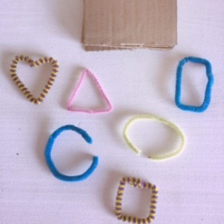
11:15-11:45 | Special - Music  PK.ARTS.9. [MU:Pr4-6.PK] Performs Music | Please see Mrs. Arco’s Class page http://arcomusicinstruction.weebly.com/
11:45-12:15 | Science/ Social studies  Students will use an empty egg crate to create a butterfly.  PK.ELAL.22. [PKSL.4] Describes familiar people, places, things and events  PK.ELAL.23. [PKSL.5] Creates a visual display (e.g., drawing, art work, building, writing) | 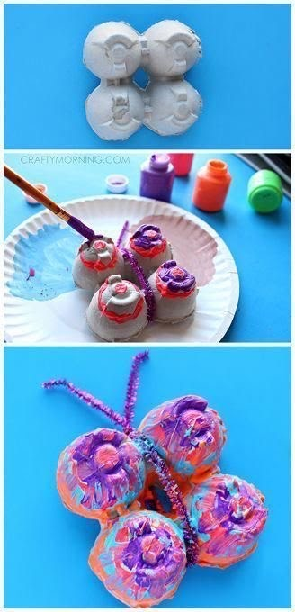  You can use markers to color if you do not have paint.  Lifecycle of a butterfly  https://www.youtube.com/watch?v=O1S8WzwLPlM
12:15-1:00 | Lunch -  PK.PDH.8. Demonstrates awareness and understanding of healthy habits | Your child can assist you in setting the table, getting the necessary items out to make lunch. (bread, cold cuts, pb, jelly, milk, plates, napkins, cups)
1:00-1:45 | Recess  PK.PDH.6. Engages in a variety of physical fitness activities | Relay race, red light green light, free play outside
1:45-2:00 | Story of choice /discuss what you learned today and what you enjoyed doing. Rest and relax!  PK.ELAL.22. [PKSL.4] Describes familiar people, places, things and events  PK.ELAL.24. [PKSL.6] Expresses thoughts, feelings, and ideas | Sample Questions: What was your favorite part of today? What did you enjoy the most?  Name one thing that you learned today?  REST TIME Music  https://www.youtube.com/watch?v=Lp6XlsBm_Lw

Date: Tuesday, 4/21
TIME | SUBJECT | RESOURCES
8:00-8:30 | Songs, calendar, weather, days of the week, letter of the week, go over the daily schedule. Talk about the day's activities.  Can we use this to make music? (display a piece of paper)  PK.SEL.6. Understands and follows routines and rules  PK.SOC.6. Develops an understanding of how people and things change over time and how to relate past events to their present and future activities  PK.SCI.8. [P-ESS2-1.] Asks questions, makes observations, and collects and records data using simple instruments to recognize patterns about how local weather conditions change daily and seasonally. | https://www.youtube.com/watch?v=0TgLtF3PMOc  https://www.youtube.com/watch?v=3jPsradyuyI
8:30-9:00 | Value of the Month: Respect  Standard: PKSEL.1.Regulates responses to needs, feelings and events. (A) Expresses feelings, needs, opinions and desires in a way that is appropriate to the situation.(D) Demonstrates an ability to independently modify behavior in different situations. | Review the definition of respect.  How can you be respectful to your family?  Talk about the ways we can show respect to family members. Make a list and turn into google classroom.
9:00-9:30 | Puzzle, game of choice  PK.PDH.5. Demonstrates eye-hand coordination and fine motor skills
9:30-9:45 | Body Break  Standard: PK.ARTS.2 Performs Dance (A) Demonstrates basic full body movements (crawl, walk, run), non locomotor movements (bend, twist, reach) and spatial relationships (over, under, around) while moving in general space. | Tooty Ta  https://www.youtube.com/watch?v=p4gNCR0HVuk  Count to 100 Workout  https://www.youtube.com/watch?v=0TgLtF3PMOc
9:45-10:30 | ELA - Read Aloud/Daily Name Writing/ Practice Writing letters  Letter of the Week S  Read Aloud - The Adventures of Harry and Gary  Standard: PKELA.1.1 Demonstrates understanding of the organization and basic features of print.(D) recognizes and names some upper/lowercase letters of the alphabet, especially those in ones own name. | Make a flower garden with your name, if you would like you can make one for each member of your family. Please feel free to share your work on google classroom if you like.  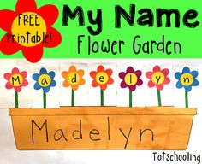  The Adventures of Harry and Gary  https://www.youtube.com/watch?v=JyJ4l-mJAVs
10:30-11:15 | Math- More or Fewer Towers  Have your child build a few different towers of different heights. Have your child tell you which tower has more blocks/fewer blocks. Repeat the process by building different towers.  Standard: PK.MATH.10. Identifies measurable attributes of objects, such as length or weight, and describes them using appropriate vocabulary(Small, med, large, big, short, tall, empty, full, heavy light)  PK.MATH.11. Sorts objects and shapes into categories: counts the objects in each category | 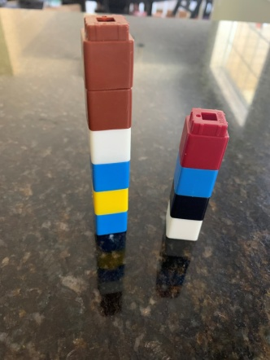
11:15-11:45 | Special - Music  PK.ARTS.9. [MU:Pr4-6.PK] Performs Music | Please see Mrs. Arco’s Class page http://arcomusicinstruction.weebly.com/
11:45-12:15 | Science/ Social studies  Trash in our environment  Standard: PK.SOC.3. Demonstrates an understanding of roles, rights, and responsibilities (D) recognizes that all children and adults have roles and rights and responsibilities at home, school, and the community. (B) Recognizes that people depend on community helpers to provide goods and services. | Discuss what we do with the trash in our environment and how we can make a difference each day. Draw a picture and describe how you can make a difference.  Recycling for Kids  https://www.youtube.com/watch?v=6jQ7y_qQYUA
12:15-1:00 | Lunch  PK.PDH.8. Demonstrates awareness and understanding of healthy habits | Your child can assist you in setting the table, getting the necessary items out to make lunch. (bread, cold cuts, pb, jelly, milk, plates, napkins, cups)
1:00-1:45 | Recess  PK.PDH.6. Engages in a variety of physical fitness activities | Relay race, red light green light, free play outside
1:45-2:00 | Story of choice /discuss what you learned today and what you enjoyed doing. Rest and relax!  PK.ELAL.22. [PKSL.4] Describes familiar people, places, things and events  PK.ELAL.24. [PKSL.6] Expresses thoughts, feelings, and ideas | Sample Questions: What was your favorite part of today? What did you enjoy the most?  Name one thing that you learned today?  REST TIME Music  https://www.youtube.com/watch?v=Lp6XlsBm_Lw

Date: 4/22 - Earth Day
TIME | SUBJECT | RESOURCES
8:00-8:30 | Songs, calendar, weather, days of the week, letter of the week, go over the daily schedule. Talk about the day's activities.  QOTD: Why do we celebrate Earth Day?  PK.SEL.6. Understands and follows routines and rules  PK.SOC.6. Develops an understanding of how people and things change over time and how to relate past events to their present and future activities  PK.SCI.8. [P-ESS2-1.] Asks questions, makes observations, and collects and records data using simple instruments to recognize patterns about how local weather conditions change daily and seasonally. | 12 Months of the Year Jack Hartmann  https://www.youtube.com/watch?v=omkuE6Wa5kQ  Days of week  https://www.youtube.com/watch?v=Oiisv7EhG98
8:30-9:00 | Value of the Month: Respect  Standard: PKSEL.1.Regulates responses to needs, feelings and events. (A) Expresses feelings, needs, opinions and desires in a way that is appropriate to the situation.(D) Demonstrates an ability to independently modify behavior in different situations.
9:00-9:30 | Puzzle, game of choice  PK.PDH.5. Demonstrates eye-hand coordination and fine motor skills | Cut up a new cereal box into a puzzle. Use various shapes and sizes (24 pieces) or (48 pieces)
9:30-9:45 | Body Break  Standard: PK.ARTS.2 Performs Dance (A) Demonstrates basic full body movements (crawl, walk, run), non locomotor movements (bend, twist, reach) and spatial relationships (over, under, around) while moving in general space. | Penguin Dance  https://www.youtube.com/watch?v=uf0uKmKwnKs  Yoga for kids with animals  https://www.youtube.com/watch?v=5XCQfYsFa3Q
9:45-10:30 | ELA - Read Aloud/Daily Name Writing/ Practice Writing letters  Standard: PKELA.1.1 Demonstrates understanding of the organization and basic features of print.(D) recognizes and names some upper/lowercase letters of the alphabet, especially those in ones own name. | Talk about the sounds each letter makes and find objects in your home that start with these letters.  The Earth Book by Todd Parr  https://www.youtube.com/watch?v=aXnWUS_K0XQ  The author has a list of 10 Things I Can Do to Help the Earth?  What is one way you can help the Earth?
10:30-11:15 | Math- | Counting with Recyclables  Have a grown-up tell you a number.  http://jdaniel4smom.com/2017/04/earth-day-math-activities-with-printables.html  Use small lids, corks, bread tags or other small treasure. Things you have at home like pom-poms, buttons or bead would be fine to use.  Count the objects until you have the number of objects that a grown-up told you.  Choose another number and play again!
11:15-11:45 | Please visit Coach L’s Google Classroom. | The class code for Coach L is  cnegs3v.
11:45-12:15 | Science/ Social studies-Mess Free Earth Painting  PK.ELAL.22. [PKSL.4] Describes familiar people, places, things and events  PK.ELAL.23. [PKSL.5] Creates a visual display (e.g., drawing, art work, building, writing) | Painting the Earth  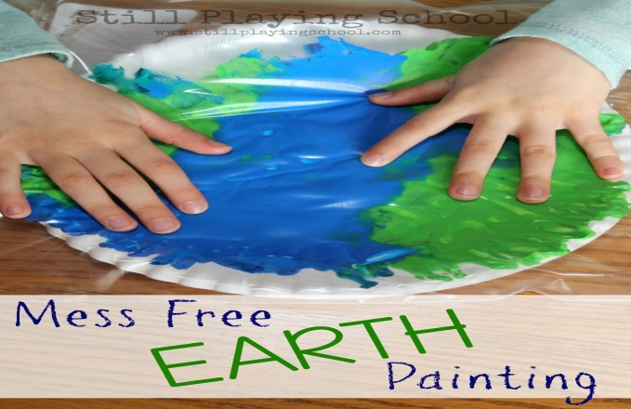  http://www.stillplayingschool.com/2015/04/no-mess-painting-in-bag-earth-craft.html
12:15-1:00 | Lunch  PK.PDH.8. Demonstrates awareness and understanding of healthy habits | Your child can assist you in setting the table, getting the necessary items out to make lunch. (bread, cold cuts, pb, jelly, milk, plates, napkins, cups)
1:00-1:45 | Recess  PK.PDH.6. Engages in a variety of physical fitness activities | Relay race, red light green light, free play outside
1:45-2:00 | Story of choice /discuss what you learned today and what you enjoyed doing. Rest and relax!  Standard: PKELA.20. {PKSL.2.} Interacts with diverse formats and texts (Shared read alouds, video clips, oral storytelling)  PKELA.22.{PKSL.4} Describes familiar people, places, things and events | Sample Questions: What was your favorite part of today? What did you enjoy the most?  Name one thing that you learned today?  REST TIME Music  https://www.youtube.com/watch?v=Lp6XlsBm_Lw

At Home Learning Schedule for UPK
Date: 4/23
TIME | SUBJECT | RESOURCES
8:00-8:30 | Songs, calendar, weather, days of the week, letter of the week, go over the daily schedule. Talk about the day's activities.  Can you use this to make music? (display a potential music maker from the junk collection)  PK.SEL.6. Understands and follows routines and rules  PK.SOC.6. Develops an understanding of how people and things change over time and how to relate past events to their present and future activities  PK.SCI.8. [P-ESS2-1.] Asks questions, makes observations, and collects and records data using simple instruments to recognize patterns about how local weather conditions change daily and seasonally. | 12 Months of the Year Jack Hartmann  https://www.youtube.com/watch?v=omkuE6Wa5kQ  Days of week  https://www.youtube.com/watch?v=Oiisv7EhG98
8:30-9:00 | Value of the Month: Respect  Standard: PKSEL.1.Regulates responses to needs, feelings and events. (A) Expresses feelings, needs, opinions and desires in a way that is appropriate to the situation.(D) Demonstrates an ability to independently modify behavior in different situations. | All About Respect  https://www.youtube.com/watch?v=TmRjyQlWyQg
9:00-9:30 | Puzzle, game of choice  PK.PDH.5. Demonstrates eye-hand coordination and fine motor skills | Cut up a new cereal box into a puzzle. Use various shapes and sizes (24 pieces) or (48 pieces)
9:30-9:45 | Body Break  Standard: PK.ARTS.2 Performs Dance (A) Demonstrates basic full body movements (crawl, walk, run), non locomotor movements (bend, twist, reach) and spatial relationships (over, under, around) while moving in general space. | Penguin Dance  https://www.youtube.com/watch?v=uf0uKmKwnKs  Yoga for kids with animals  https://www.youtube.com/watch?v=5XCQfYsFa3Q
9:45-10:30 | ELA - Read Aloud/Daily Name Writing/ Practice Writing letters  Read Aloud - The Paper Bag Princess  Puppet Making for paper bag princess.  Standard: PKELA.1.1 Demonstrates understanding of the organization and basic features of print.(D) recognizes and names some upper/lowercase letters of the alphabet, especially those in ones own name. | The Paper Bag Princess  https://www.youtube.com/watch?v=Pm7AUymn6WE  Have your child retell you the story to you and discuss the themes. (Theme - beauty is more than skin deep, don't underestimate your intelligence, love is powerful, be persistent, sometimes it takes something life changing to find ourselves)  There are puppets for your child to make to help aid in the retelling of the story on Google Classroom.
10:30-11:15 | Math- Patterns with Rocks and Sticks  Standard: PK.MATH.9. Duplicates and extends simple patterns using concrete objects (what comes next?) | Gather small rocks and sticks from outside and create various patterns. Take a photo and share on google classroom.  Example of pattern types  ABABABAB - rock/stick/rock/stick  AABBAABB - rock,rock/stick,stick  AAAbAAAb - rock,rock,rock/stick/rock,rock,rock
11:15-11:45 | Special -Library  PK.ELAL.20. [PKSL.2] Interacts with diverse formats and texts | Please see Miss D’s Class page http://arcomusicinstruction.weebly.com/
11:45-12:15 | Science/ Social studies  Standard: PK.SOC.3. Demonstrates an understanding of roles, rights, and responsibilities (D) recognizes that all children and adults have roles and rights and responsibilities at home, school, and the community. PK.ARTS.16.a Engages in self-directed imaginative play with a variety of materials and/or art-making tools  PK.ARTS.16.b Creates, shares and/or talks about art that communicates a familiar place or object | Log in to Seesaw.me to view the activity called “Rethink and Reuse.”  Follow the directions on Seesaw to complete and save the activity.
12:15-1:00 | Lunch  PK.PDH.8. Demonstrates awareness and understanding of healthy habits | Your child can assist you in setting the table, getting the necessary items out to make lunch. (bread, cold cuts, pb, jelly, milk, plates, napkins, cups)
1:00-1:45 | Recess  PK.PDH.6. Engages in a variety of physical fitness activities | Relay race, red light green light, free play outside
1:45-2:00 | Story of choice /discuss what you learned today and what you enjoyed doing. Rest and relax!  Standard: PKELA.20. {PKSL.2.} Interacts with diverse formats and texts (Shared read alouds, video clips, oral storytelling)  PKELA.22.{PKSL.4} Describes familiar people, places, things and events | Sample Questions: What was your favorite part of today? What did you enjoy the most?  Name one thing that you learned today?  REST TIME Music  https://www.youtube.com/watch?v=Lp6XlsBm_Lw

At Home Learning Schedule for UPK
Date: 4/24
TIME | SUBJECT | RESOURCES
8:00-8:30 | Songs, calendar, weather, days of the week, letter of the week, go over the daily schedule. Talk about the day's activities.  QOTD:Can we make something from a paper bag?  PK.SEL.6. Understands and follows routines and rules  PK.SOC.6. Develops an understanding of how people and things change over time and how to relate past events to their present and future activities  PK.SCI.8. [P-ESS2-1.] Asks questions, makes observations, and collects and records data using simple instruments to recognize patterns about how local weather conditions change daily and seasonally. | https://www.youtube.com/watch?v=WP1blVh1ZQM  What can you make with a paper bag? Share your creations on Google Classroom.
8:30-9:00 | Value of the Month: Respect  Praise your child every time they use their manners today!  PK.SOC.1. Develops a basic awareness of self as an individual, self within the context of group, and self within the context of community | When a child demonstrates good manners, praise them for this respectful behavior.  Examples:  - I love how you are sharing your Legos with your brother/sister.  - I appreciate how you are helping to set the table.  - I like how you said please/thank you!
9:00-9:30 | Puzzle, game of choice  PK.PDH.5. Demonstrates eye-hand coordination and fine motor skills
9:30-9:45 | Body Break  Standard: PK.ARTS.2 Performs Dance (A) Demonstrates basic full body movements (crawl, walk, run), non locomotor movements (bend, twist, reach) and spatial relationships (over, under, around) while moving in general space. | Dance and Freeze  https://www.youtube.com/watch?v=1iDscTioa8E  Shake your sillies out  https://www.youtube.com/watch?v=NwT5oX_mqS0  Good Morning Song  https://www.youtube.com/watch?v=3jPsradyuyI
9:45-10:30 | ELA - Read Aloud/Daily Name Writing/ Practice Writing letters  Daily Name Writing - First and last name  Read Aloud - Peter's Chair  Standard: PKELA.1. Demonstrates understanding of the organization and basic features of print.(D) recognizes and names some upper/lowercase letters of the alphabet, especially those in one’s own name. | Peter's Chair read aloud  https://www.youtube.com/watch?v=fZ7ayY6Yvec
10:30-11:15 | Math-  Recyclables in a Line  Standard: PK.MATH.7 Identifies first and last related to order or position  PK.PDH.5.a Demonstrates ability to use fine motor skills (e.g., uses materials such as computer mouse, fingers on a tablet, or drawing tool)  PK.AC.2 Demonstrates they are building background knowlege  PK.AC.2.c Attempts to use new vocabulary correctly (e.g. names of items that we can recycle, order words like first, middle, last) | Log in to Seesaw.me to view the activity called “Recyclables in a Line.”  Follow the directions on Seesaw to complete and save the activity.
11:15-11:45 | Special - Show and Tell  PK.AC.1. Demonstrates motivation to communicate  PK.AC.2. Demonstrates they are building background knowledge | Find an item for each of the letters M-R. Put on a presentation for family members.
11:45-12:15 | Science/ Social studies  STEM-Junkbot Robots Building-using your recyclables have your child build a junkbot!  PK.ELAL.23. [PKSL.5] Creates a visual display  PK.SCI.11. [K-2-ETS1-2.] Develops a simple sketch, drawing, or physical model to illustrate how the shape of an object helps it function as needed to solve a given problem | 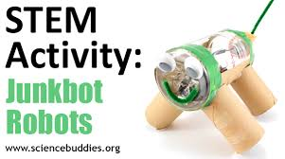
12:15-1:00 | Lunch  PK.PDH.8. Demonstrates awareness and understanding of healthy habits | Your child can assist you in setting the table, getting the necessary items out to make lunch. (bread, cold cuts, pb, jelly, milk, plates, napkins, cups)
1:00-1:45 | Recess  PK.PDH.6. Engages in a variety of physical fitness activities | Relay race, red light green light, free play outside
1:45-2:00 | Story of choice /discuss what you learned today and what you enjoyed doing. Rest and relax!  Standard: PK.ELAL.20. {PKSL.2.} Interacts with diverse formats and texts (Shared read alouds, video clips, oral storytelling)  PK.ELAL.22.{PKSL.4} Describes familiar people, places, things and events | Sample Questions: What was your favorite part of today? What did you enjoy the most?  Name one thing that you learned today?  REST TIME Music  https://www.youtube.com/watch?v=Lp6XlsBm_Lw

