Assignments for 3/23
TIME | SUBJECT | RESOURCES
8:00-8:30 | Songs, calendar, weather, days of the week, letter of the week, go over the daily schedule. Talk about the day's activities.  Question Of The Day (QOTD): What did you throw away today? | Jack Hartmann “12 Months of the Year”  https://www.youtube.com/watch?v=omkuE6Wa5kQ  Days of week  https://www.youtube.com/watch?v=Oiisv7EhG98
8:30-9:00 | Value of the Month: Compassion - Discuss what compassion is and talk about ways we can be compassionate to others.  After watching the video, ask “What did the dog do to show compassion to the bird? Why?” | A Short Story on Kindness  https://www.youtube.com/watch?v=8Wi0UWLeT9I
9:00-9:30 | Puzzle, game of choice | Cut up a cereal box in pieces and see if your child can put it back together.
9:30-9:45 | Body Break | Sing “Head, Shoulder, Knees and Toes” to stretch and move.
9:45-10:30 | ELA - Read Aloud/Daily Name Writing/ Practice Writing letters  Story: Something From Nothing. After listening to the story, ask students “How did Joseph make something from nothing?”  Have students write recycling words with an unsharpened pencil or finger in a salt tray (sugar or flour).  Trace one letter sheet (We are reviewing letters A-F this week). | Story Link: https://www.youtube.com/watch?v=vHzav9BS-Fc  Recycling Words  See words in Google Classroom  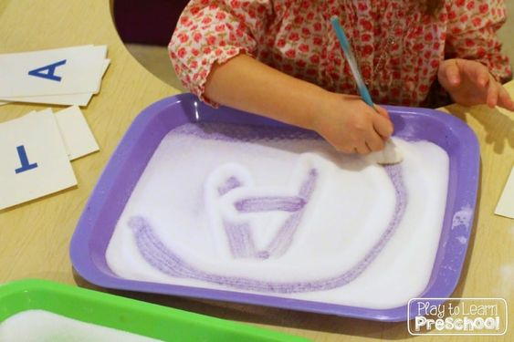
10:30-11:15 | Math- Story Problems  Complete one math tracing sheet | See PDF-Labeled Math Story Problems
11:15-11:45 | Special - Music | Please see Mrs. Arco’s Class page http://arcomusicinstruction.weebly.com/
11:45-12:15 | Science/ Social studies  Recycling Question: What did you throw away today? Where did you put it (garbage can, recycling)? | Have students respond to this question and share his/her response with teacher via Google Classroom or email.
12:15-1:00 | Lunch | Your child can assist you in setting the table, getting the necessary items out to make lunch. (bread, cold cuts, pb, jelly, milk, plates, napkins, cups)
1:00-1:45 | Recess | Relay race, red light green light, free play outside
1:45-2:00 | Story of choice /discuss what you learned today and what you enjoyed doing. Rest and relax! | Sample Questions: What was your favorite part of today? What did you enjoy the most?  Name one thing that you learned today?

